Abstract

A rapid, highly sensitive high performance liquid chromatographic method has been developed
for the determination of Lenalidomide in bulk drug and in capsules. Lenalidomide was eluted
from a Inertsil C8 reversed-phase column with a mobile phase consisting of methanol: water
(70:30 v/v) pH 9 at a flow rate of I mWmin with UV detection at 395 nm. The retention time
for Lenalidomide was 6.64 ± 0.05 min. The linear response (r 2 — 0.9991) was observed in the
range of 2 - 12 gg/mL with limits ofdetection (LOD) and quantification (LOQ) being 0.13 and
0.39 gg/ml, respectively. The method shows good recoveries and intra and inter-day relative
standard deviations were less than 2.0%. Validation parameters as specificity, accuracy,
ruggedness and robustness were also determined. The proposed method provides accurate and
precise quality control tool for routine analysis of Lenalidomide in bulk and in capsule dosage form.
Keywords: Lenalidomide, RP-HPLC, Method Development, Method Validation, ICH
Guidelines

Introduction
Analytical Chemistry [1-6]
Analytical chemistry is one of the key branches of chemistry involved in the separation, identification and estimation of the components of natural and artificial materials. Advanced analytical chemistry involves the separation and identification of chemical substances by means of several techniques (chromatography, spectroscopy and electroanalytical). Analytical chemistry is used to guarantee quality and purity in the pharmaceutical industry and to track pollutants in the air, water and soil in environmental science. The field is also very important in fields of food safety, forensic science and material science, enabling information about the composition and properties of substances. As chemistry evolves, analytical chemistry continues to develop new methods and techniques that help scientists understand complex chemical systems, driving innovation in the field and its applications in industries all over the world. Analytical chemistry is a basic branch of the chemical sciences which deals with the careful and accurate analysis of chemical substances. This employs advanced methods and apparatus that allow the separation, identification and measurement of matter, even in the most complex mixtures with the utmost accuracy. The chemical composition of samples like pharmaceuticals, environmental contaminants, food products and forensic materials are usually analysed using analytical techniques such as gas chromatography (GC), high-performance liquid chromatography (HPLC), mass spectrometry (MS) and High-performance liquid chromatography-mass spectroscopy.
Analytical chemistry plays a vital role in the pharmaceutical industry, playing a critical role in the development of new medicines by conducting detailed testing and quality control processes to ensure their effectiveness and safety. Analytical techniques are used by environmental scientists to identify and quantify pollutants, which is important in protecting ecosystems and human health. To ensure the food product is pure and safe, and meets nutritional requirements, these techniques are used by food scientists. Analytical chemistry is used in forensic science to analyze evidence found at a crime scene to help solve a case.
It also involves the creation of new analytical techniques and the refinement of existing ones, as technology evolves and the knowledge and understanding of chemistry continues to grow. The innovations increase the sensitivity, specificity and speed of analysis, thus expanding the range of the analysis and detection possibilities. Analytical chemistry is closely related to several scientific and industrial fields, and the quantitative and qualitative information it affords is fundamental to the progress of knowledge, to safety and to innovation. Analytical chemistry lies at the core of both scientific research and industrial application, and serves as the link between theory and practice. It includes many techniques which enable scientists to explore the molecular and atomic structure of a substance and give them an important clue to its composition and properties. Methods such as chromatography (including liquid chromatography (LC) and gas chromatography (GC)) help to separate complex mixtures into their component parts, allowing the individual components to be identified and quantified precisely.
Spectroscopic techniques, including ultraviolet-visible (UV-Vis) spectroscopy, infrared (IR) spectroscopy, and nuclear magnetic resonance (NMR) spectroscopy, use light to gain detailed information on molecular structure and dynamics. Mass spectrometry (MS) is extremely useful for the identification of unknown compounds and elucidation of chemical structure because it allows determination of mass-to-charge ratio (m/z). The electroanalytical methods based on the measurement of electrical characteristics for analysis of chemical substances (potentiometry, voltammetry) have high sensitivity and selectivity.
Analytical chemistry plays an important role in environmental science for monitoring pollutants and in evaluating the health of the environment. It helps to detect trace amounts of contaminants in air, water and soil which helps to protect human health and the environment. In the pharmaceutical sector, precise analysis is crucial for maintaining high-quality, safe, and effective drugs, both in their development and production stages. Analytical chemists develop methods for the detection of impurities, verification of the composition of active ingredients and compliance with regulatory standards.
Analytical chemistry has a crucial role in food and beverage industries in quality control and safety assurance. Analytical techniques are employed to identify contaminants, to confirm the claims on products and to ensure that products comply with nutritional requirements. Analytical methods are key in forensic science, as they must be precise and reliable to analyze evidence, ranging from determining what substances are present to connecting suspects to crime scenes.
Analytical chemistry is a dynamic and rapidly developing field of chemistry with the new development of the technology and methodology. Analytical chemists are seeing some exciting innovations, including high-resolution mass spectrometry, microfluidics and lab-on-a-chip devices, that allow scientists to analyze more quickly, sensitively and thoroughly. These innovations not only propel a better understanding of the world, but they also have real-world applications that boost the quality of life, ranging from improved health care solutions to better environmental monitoring. Overall, analytical chemistry plays a fundamental role in science and industry, enabling the investigation, understanding and manipulation of chemical substances. It's essential in many industries, contributing significantly to progress and safety, effectiveness, and compliance in diverse applications. Instrumental analytical techniques are also some of the most crucial tools that have been used in the modern-day analytical chemistry which enable the precise and accurate analysis of chemical substance. These techniques are used to separate, identify and measure components in a range of samples, making use of sophisticated instruments.

Advantages of instrumental methods
- Small samples can be used
- High sensitivity is obtained
- Reliable measurements
- Fast determination
- Capable of analyzing complex compounds and easy to handle.

Limitations of instrumental methods
- High cost of instruments and maintenance
- Requirement of skilled and trained personnel
- Need for regular calibration and validation
- Dependence on electricity and controlled laboratory conditions
- Possibility of instrumental errors and interference
- Complex sample preparation in some techniques
- Limited portability for certain sophisticated instruments
- High consumption of solvents, reagents, and consumables
- Time-consuming method development and optimization
- Sensitivity to environmental conditions such as temperature and humidity

Principal types of chemical instrumentation
- Spectrometric techniques
  - Ultraviolet–visible (UV–Vis) spectrophotometry

  - Fluorescence and phosphorescence spectroscopy
  - Atomic spectroscopy involving emission and absorption measurements
  - Infrared (IR) spectroscopy
  - Raman spectroscopic analysis
  - X-ray spectroscopic methods
  - Radiochemical analytical methods, including activation analysis
  - Nuclear magnetic resonance (NMR) spectroscopy
  - Electron spin resonance (ESR) spectroscopy

Electrochemical Techniques
  - Potentiometric analysis
  - Voltametric techniques
  - Stripping analysis methods
  - Amperometric measurements
  - Colorimetric analysis
  - Electrogravimetric methods
  - Conductometric techniques

Chromatographic Techniques
  - Gas chromatography (GC)
  - High-performance liquid chromatography (HPLC)
  - Thin-layer chromatography (TLC)
  - High-performance thin-layer chromatography (HPTLC)

Miscellaneous Techniques
  - Thermal analytical techniques
  - Mass spectrometric analysis
  - Kinetic-based analytical methods

Hyphenated Techniques
  - Gas chromatography coupled with mass spectrometry (GC–MS)
  - Tandem mass spectrometry (MS–MS)
  - Gas chromatography combined with infrared spectroscopy (GC–IR)
  - High-performance liquid chromatography linked with mass spectrometry (HPLC– MS)
  - Liquid chromatography coupled with tandem mass spectrometry (LC–MS/MS)
  - Liquid chromatography integrated with mass spectrometry and nuclear magnetic resonance spectroscopy (LC–MS–NMR)

  - Liquid chromatography combined with nuclear magnetic resonance spectroscopy (LC–NMR)
  - Capillary electrophoresis interfaced with mass spectrometry (CE–MS)
Analytical Method development [7-8]
Method development is done
- for new products
- for existing products
If an official procedure is not available, analytical methods are developed for newly introduced products. For existing non-pharmacopoeial products, alternative methods are intended to enhance the accuracy and robustness, and to decrease the analysis time and cost. Each of these methods is validated using trial experimentation, optimized and then validated. Where a new method is suggested as an alternative to an accepted one, comparative laboratory information outlining merits and drawbacks is also included.

Selection of analytical method
The method of analysis chosen is an important decision to make for the accuracy and reliability of the analytical results. Selection of the most appropriate technique or set of techniques to fulfill the goals of the analytical problem is a matter of choosing, with respect to a number of considerations, the technique or techniques that best accomplish the goals:

Objectives of the Analysis:
    - o Identify if the goal is to be qualitative, quantitative, or both. This will affect the method/technique chosen.

Nature of the Sample:
    - Sample Matrix: Determine the complexity of sample matrix and interferences. Complex matrices may need to be treated with a method that is capable of dealing with them, such as liquid-liquid extraction or solid-phase extraction.
    - Physical and Chemical Properties: Take volatility, polarity and solubility into account. Gas chromatography (GC) is good for volatile compounds and high-performance liquid chromatography (HPLC) is good for polar compounds.

Analytical Requirements:

    - Detection Limits: Determine sensitivity for the detection and quantification of analytes at desired concentrations. There are methods such as mass spectrometry (MS) which can be used for the detection of traces with high sensitivity.
    - Accuracy and Precision: Make sure that the method is reliable and reproducible. This includes providing the method with a strict test and calibration.

Instrumental Capabilities:
    - Availability: Consider the availability of the required instruments and equipment. Choose methods that can be performed with the resources and technology available.
    - Expertise: Ensure that the analytical personnel are trained and proficient in using the chosen technique.

Practical Constraints:
    - Cost: Evaluate the cost of the method, including the expense of equipment, reagents, and maintenance. Balance cost against the required performance and accuracy.
    - Time: Consider the time required for sample preparation, analysis, and data processing. Some methods may be faster or more efficient than others.

Regulatory and Compliance Considerations:
    - Standards and Guidelines: Make sure that the method meets industry regulations and standards, including those established by the FDA, EPA, or ISO. Adherence to these standards is crucial for quality assurance and regulatory approval.

Method Development and Optimization:
    - Development: Customize and optimize the method to fit the specific requirements of the analysis. This may involve adjusting parameters such as temperature, flow rates, and detection wavelengths.
    - Validation: Conduct method validation to confirm its suitability for the intended application. This includes testing for accuracy, precision, specificity, and robustness.
By systematically evaluating these factors, analysts can select the most appropriate analytical method that meets the specific needs of their analysis, ensuring high-

quality, reliable results that support informed decision-making and compliance with relevant standards.
To be entirely optimized before transfer for validation of its characteristics such as accuracy, precision, sensitivity, ruggedness etc. For analyzing the drugs samples in bulk, pharmaceutical formulations and biological fluids, different analytical methods are routinely being used. These analytical methods are classified as classical and instrumental.
Instrumental analytical techniques are generally easier to perform, more accurate, and more reproducible than conventional classical methods. Consequently, analytical procedures developed using advanced instruments such as spectrophotometers, High-Performance Liquid Chromatography (HPLC), Gas Chromatography (GC), and High-Performance Thin-Layer Chromatography (HPTLC) are extensively employed for the qualitative and quantitative assessment of raw materials as well as finished pharmaceutical products.

Steps of method development
- Characterization of the analyte standard
- Defining the method requirements
- Review of literature and existing methodologies
- Selection of an appropriate analytical method
- Instrument setup and preliminary studies
- Method optimization
- Documentation of analytical performance characteristics
- Evaluation of the developed method using actual samples
- Determination of percentage recovery from the sample matrix
- Validation of the analytical method

CHROMATOGRAPHY [9-14]
Separation, identification as well as purification of the constituents present in composite mixture are done with one of the significant analytical technique-chromatography. The components of the mixture may differ in size or molecular weight. Both quantitative as well as qualitative analysis are performed with chromatography for components in complex combination. Chromatography is not only science but also art in separating analytes existing as complex mixtures. It includes the process of physical separation that yields individual components of interest. However chromatographic technique is only applicable if the components are just mixed together physically, in case of chemically combined elements separation, identification and quantification may not be viable.

Principle of Chromatography
The basic principle involved in chromatography is stationary phase(it may include fluid stationary phase) or solid surface phase onto or into which the mixture containing components, molecules or substances to be separated are applied with the aid of mobile phase that moves from one end to other of stationary phase. The fact of separation is governed with many factors like molecular characteristics associated to adsorption of components, molecular weight, partition coefficient as well as affinity of elements under study and which are being separated. The variation in the size or molecular weight of individual element in the mixture results in retention of some components and they move gradually through system while others are moving rapidly with mobile phase and departing quickly from the system.

Terms Used in Chromatography Mobile Phase
Moving part in chromatographic system is termed as mobile phase, generally the sample is dissolved in mobile phase. The composition of the mobile phase consists of liquids, gases, even supercritical fluids. It is necessary and of significant value that components under study that are being separated should always be compatible with mobile phase.

Stationary Phase
The stagnant phase over which mobile phase is forced to move is referred to as stationary phase. The composition of the stationary phase includes solid stand, sometimes layer of liquid placed on the surface of solid support.

Supporting Medium
A solid surface over which stationary phase either in the form of layer or liquid spread referred as supporting medium. When the mobile phase is permitted to move on it distribution of analytes between two phases occurs on the basis of partition coefficient or affinity.

Elute
After completing the chromatographic procedure, the component obtained is referred as elute.

Eluent
The part of mobile phase that acts as carrier is eluent. The movement of analyte among chromatographic apparatus is governed by eluent.

Elution
Under the influence of moving solvent, the event of extracting absorbed component or substance is referred to as elution.

Chromatogram
A graphical representation of responses of the detectors as function of elution time, band’s position, shape, resolution is termed as chromatogram.

Retention Time
The following injection of the sample into the column time taken by individual solute to reach detector is known as retention time.
TYPES OF CHROMATOGRAPHY
Based on the Nature of Mobile Phase:
Liquid Chromatography
This analytical technique includes mobile phase in the form of liquid solvent employed in separation of elements or components present in liquid samples. It also consists of stationary phase as column that contains solid beads.

Gas Chromatography
The major application of this technique is separation of vaporized samples with aid of carrier gas which serves as mobile phase while the stationary phase composed of column containing liquid or solid beads.

Paper Chromatography
In this technique the paper strip utilized as stationary phase while it is employed in separation of dried liquid samples using liquid solvents as mobile phase.

Thin Layer Chromatography
This technique uses glass plate covered with thin layer of silica or alumina gel while liquid solvents served as mobile phase which are employed in separation of dried liquid samples.

Based on the Mechanism of Separation Partition Chromatography
Separation occurs based on variation in partition coefficients of components or substances under study in this kind of chromatography. Distribution between two mobile phases is not uncommon and occurs due to diversity in partition coefficients. Even the partition of molecules into the stationary phase happens based on affinity towards stationary phase finally it again elutes in mobile phase.

Adsorption Chromatography
As the name indicates this type of chromatography is founded on the principle of adsorption. The components are separated based on interaction between adsorbate and adsorbent. The solid surface acts as adsorbent while the components in the mixture served as adsorbates that are likely to be get adsorbed on the stationary phase. The concept of adsorption chromatography is much like partition chromatography. The components under study are adsorbed on the solid or stationary surfaces.

Ion-Exchange Chromatography
In this sort of chromatography, the separation of the polar molecules or ions is done based on their affinity to ion exchanger which served as stationary phase. Molecules possessing any kind of charge like small nucleotides, larger amino acids, proteins are separated using ion-exchange chromatography. Either anions or cations are separated by means of ion-exchange chromatography. The relative strength of ionic bond affects the separation by ion-exchange chromatography.

Molecular Exclusion Chromatography
It is also referred to as gel permeation chromatography as well as size exclusion chromatography. In this technique separation is observed on the basis of size or molecular weight of component under study. The mechanism of separation involves filtration through gel where it served as stationary phase. This gel comprised of hetero porous cross-linked polymeric beads. Molecules with smaller size get trapped into the pores while the molecules with larger size avoid entering the pores and able to run greater distance in gel. The retardation of molecules under study while in flow of governed based on size of the components. The large molecules tend to elute quickly as they cannot enter the stationary phase on the cost of their larger size or higher molecular weight.

Gel Electrophoresis
It is a technique employed in separation of DNA, RNA and protein molecules based on their molecular sizes. This technique involves pushing molecules of interest under influence of electrical field throughout gel that served as stationary phase and consists of small pores. At one end of the gel injection of components under study into the wells is done while from other end application of electric current is perceived to pull components through gel. While the electric current is employed, the negatively charged fragments of the components travel towards the positive electrode. It is important to note that all fragments do possess the same extent of charge per mass ratio this causes smaller fragments to travel through gel rapidly and with ease than molecules with larger size.

Affinity Chromatography
This type of chromatographic technique involves specific binding interaction in adsorption which is guided by particular affinity. This affinity between binding partner which is component of interest and immobilized ligand that is fasten on the stationary phase. In this case stationary phase and mobile phase interacts in usual reversible manner while separation is accomplished with biphasic interaction occurring between the ligand which is immobilized on stationary phase and target component under study that exists in mobile phase.

Applications of Chromatography
Pharmaceutical sector gives major emphasis on purity and quality and hence the samples are analyzed for detection of trace elements, separating compounds on the basis of elemental composition or molecular weight, purity of mixture or determination of unknown compound may be followed by its identification.
Detection of alcohol and narcotics from biological samples like blood or urine is done with chromatographic techniques in hospitals.
Agencies involved in environment protection rely on chromatographic techniques to detect the presence of pollutants in the environment.
In the food industry, estimation of spoilage, presence of additive or certain impurities, quality of nutritional components is determined with chromatographic techniques.
The forensics department uses chromatographic techniques to test crime scenes, even for forensic pathology, and arson investigation.

In molecular biology, redox reactions involving bioorganic molecules, also characterization of reaction mixtures while studying biomolecules is done with chromatographic techniques.
In metabolomics, imitating biotransformation reactions is a crucial task performed with chromatographic techniques. E.g., In drug metabolism study, Phase I oxidative reactions.
Chromatographic techniques are utilized in analysis of oxidation of biomolecules like proteins and peptides. Even during development chromatographic techniques are employed in purifying monoclonal antibodies, vaccines, plasma proteins and hormones while studying proteomics.
Chromatographic techniques also find their application in nucleic acid research which is used in identifying oxidation products of nucleotides, nucleosides, nucleobases.

HIGH PERFORMANCE LIQUID CHROMATOGRAPHY [15-19]
Kirkland and Huber were the first to propose a system of High-performance liquid chromatography. In 1970, the HPLC system was developed with the central principle of column chromatography. The components existing in mixture or dissolved in sample solution are separated using HPLC which is form of liquid chromatography. Its functioning includes passing mobile phase through a packed column by pumping it under high pressure of about 3000 psi hence it is also termed as High-pressure liquid chromatography. When the sample is injected into the column separation of components in the mixture is achieved. The components in the mixture under study, though added simultaneously passed and leave the column at different time due to behavior of individual component governed by phenomenon of partition and adsorption. The process of introducing mobile phase under pressure pumping into the stationary phase in the form of column brings superiority to the system of HPLC and makes it unique.

Types of HPLC Techniques
Based on Mode of Chromatography
- Normal phase: As the name suggests, this kind of HPLC system uses a non-polar mobile phase and a polar stationary phase. The non- polar molecules possessing higher affinity towards non-polar mobile phase moved rapidly from polar stationary phase and eluted earlier as compared to their polar counterparts which get retained in stationary phase on the cost of their affinity towards

stationary phase. It obeys simple rule polar molecules get retained on polar medium while non-polar molecules show suitability to travel with non-polar medium. In this type of chromatography, the polar molecules under study depict better retention on the polar stationary phase and their elution occurs lately on the cost of their affinity towards polar stationary phase. In this way separation of molecules in the mixture occurs based on their polarity differences affecting their affinity among two phases.
- Reverse phase: This HPLC technique involves use of non-polar stationary phase while the mobile phase employed is polar in nature. In this case the polar components moved quickly and are eluted first while the non-polar components under study take more time to elute as they are retained among non-polar stationary phase. While the polar molecules do not tend to get retained on the non-polar stationary medium and hence are eluted rapidly without spending much time in column that contains non-polar beads.

Classification based on the Principle of Separation
There are several HPLC techniques which are based on the principle of separation that are as follows:
- Ion exchange chromatography.
- Adsorption chromatography.
- Size exclusion chromatography.
- Affinity chromatography.
- Partition chromatography.

Classification based of Operation
The scale of operation yields mainly two types of system discussed as follows:
- Analytical HPLC: Generally analytical HPLC works on small quantity of analyte also it is destructive in nature that means recovery of analyte under study is almost impossible.
- Preparative HPLC: This is a modified version of an analytical system which collects particular components of interest with the use of fraction collector. This system collects analyzed components.

Classification based on the Purpose of Analysis
Based on purposes two techniques of analysis are there using HPLC technique.

- Qualitative HPLC: It mainly deals with identification of the component and reveals its characteristics. It separates the components from the sample mixture.
- Quantitative HPLC: This type of analysis aims towards determining the number of components present in sample mixture. It is followed by identification and integration.

HPLC System
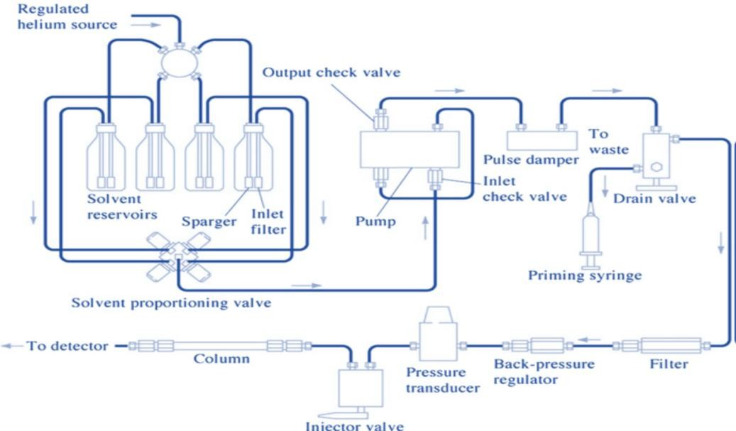
The HPLC system’s schematic representation described in Fig.1.6

Figure 1.5: HPLC system: A schematic representation

Components of HPLC System
The major components of HPLC system are as follows:

Solvent Reservoir
In general, mobile phase employed in HPLC system composed of blend of polar and non-polar solvents to ensure proper separation. Depending on the sample under study the concentration of different components in mobile phase varies. Hence the mobile phase components are kept in separate glass reservoirs to reserve the mobile phase. Inert material such as glass is employed in making reservoirs also it is designed to prevent access of microbes if any.

Pump

Pumps perform the function of aspiring mobile phase into the system from the reservoir. Pumps are used to enforce it through the column while maintaining desired flow rate which is expressed as mL/min. Usually flow rate of 1-2 mL/min is required in HPLC systems. It is possible to deliver mobile phase in both isocratic and gradient mode using pumps. Following characteristics are expected from pump for smooth functioning.
- Constant flow rate
- Non-corrosive
- Ability to bear the applied pressure generating from flow of mobile phase.
- Compatibility with mobile phase

Types of Pumps
HPLC technique uses two types of pumps, discussed as follows
- Constant pressure pumps: In this type of pumps continuous flow rate is achieved with gas in cylinder however it got some restrictions like limited reservoir also it permits non-pulsating flow. E.g., displacement type pumps.
- Constant volume pumps: These pumps permit mobile phase to flow into the column withstanding high pressure. E.g., Syringe pumps, pressure vessel pumps, reciprocating type pumps.

Sample Injector
Introduction of the liquid sample in the HPLC is carried out with injector. Sample injecting is a delicate process and precautions must be taken to avoid disturbing column packing. Following this way, the entry of liquid sample directly occurs in the flow stream of mobile phase within column. Two types of injectors can be used in HPLC system. The first is single injection while the other is automated injection system. The injector must be able to endure the pressure built in the system. Usually, 5-20 μL volume of sample may be injected.
Manual Injector
A manual injector is a device that holds a metered amount of liquid sample before injecting it into the system. It has got many components. First it contains a valve, in case of direct injection of the liquid sample into the eluent stream valve employed to maintain the path of sample. After pump head injection is positioned while the introduction of sample is done in load mode. Loading is done by microsyringe maintained under highly controlled conditions. Storage of injected solution is done in

sample loop. The sampling system also employed injection valve for introducing predetermined quantity of sample with unchanged pressure of sample. With rotation of knob to injection mode the sample flow out from the loop and go into the eluent stream.
Auto sampler
Autosampler consists of automated implementation of injection process. This is operated using a micro syringe. This phenomenon works based on computer-controlled programs. However, this process may be performed by the analyst using machines manually. The major advantage of autosampler is injection of large amount of sample.
Pressure Injection Method
This method involves 6-port valve which is attached to sample loop. When a particular quantity of sample delivered from sample enters sample loop, switching of valve takes place so that eluent is carried to the loop followed by subsequent delivery of the sample into the column. In simple words, some procedures executed by analyst with manual injector are accomplished by machines.
Total-Volume Injection Method
This method includes the process of introduction of programmed quantity of sample into a tube from vial followed by eluent directly delivered into the tube. Due to this sample reaches the column. The flow of eluent inside the needle at a different time than that of injection operation is main advantage of the method. Also with a very minute loss of sample carrying volume greater than conveyed to column is among other benefits of the system. The fluid entering the system must be degassed as it is almost not possible to articulate precise quantity of the sample on the cost of air bubbles from fluids in the track between measuring pump to column needle tip.

Column
Generally heavy glass material or polished stainless steel are among materials employed to make columns as it has to endure high pressure generated during operation. Columns are in the shape of narrow tubes and contain 25μm particles packed within. It is necessary that the internal portion of the column must be smooth and uniform with average internal diameter 4.6 mm. On an average the column length should be 10-25 cm long. The columns are packed with stationary phase that usually occurs in the form of porous packing of silica usually having particle size in the range of 3–10 μm. While

pellicular packing comprises 30-40 μm diameter of non-porous polymer or glass beads. Microbore columns are the one having internal diameter around less than 2 mm. It is necessary to maintain the temperature constant of mobile phase and column during the complete procedure. The generally employed columns for HPLC techniques are:
- Analytical columns: In order to execute quantitative analysis these columns are employed commonly they use UV-VIS detectors.
- Preparative columns: The prime objective of using these columns is to collect individual fractions of the elements of interest that are present in combination in sample.
- Narrow bar columns: This type of column is also employed with UV-VIS , MS or fluorescence detector but are only 1-2 mm in length. In cases where higher sensitivity is expected for the separation these columns are preferred.
- Capillary columns: The length of capillary column is 0.3 mm and fused silica is used in their making while substitute detection systems like MS detectors are essential for their use.
- Guard columns: These columns are used to enhance the lifespan of the column and are short in length. The placing of this type of column is in between sample injector and column. The protection of the column from particular matter or loss of efficiency or substance adsorbed strongly in mobile phase or sample is prime objective of this type of column.

Detector
The function of detector is of utmost importance as it determines individual element which is moving out from the column which further assists in analyzing quantitatively the component under study which has been separated out of sample mixture. Further detectors make available an output to the recorder or computer which generates chromatogram followed by interpreting the results. The detectors commonly employed in HPLC are as follows:
- UV/Visible detector.
- Photodiode array detector.
- Refractive index detector.
- Fluorescence detector.
- Evaporative light scattering detector.

- Amperometry detector.
- Potentiometric detector.
- Electrochemical detector.

Computer System
The computer system assists in controlling by and large the module of HPLC, but it also plays a major role in receiving signals from detector followed by interpreting them to estimate retention time of sample. It helps in qualitative analysis of samples and affix quantity of sample required for quantitative analysis.

Factors Affecting on HPLC
Among the factors that severely influence the functioning of HPLC system are thickness of the stationary phase and particle size of beads packed in column, flow rate, internal diameter of the column, viscosity and nature of mobile phase, affinity of analyte among both phases, pressure of pump, size of sample, size of injection volume, column packing, sample injections methods and most importantly retention time.

Advantages of HPLC
The most important advantage of HPLC is it is rapid and highly time saving; also it delivers high performance while maintaining extreme sensitivity. HPLC finds its application for qualitative and quantitative determination in analytical as well as preparative domain.

Disadvantages
Certain components get irreversibly adsorbed on the stationary phase as it never elutes and its determination is not possible. Cost is one of the major limiting factors while it is also much more complex and requires maintenance.

Applications
HPLC is one of the useful techniques in analysis and it is employed in separating inorganic ions and plant-based bioactive compounds. It finds application in determining intoxicants, poisons or addictive drugs in human plasma. Even identification of biomolecules like bile acids, steroid hormones, lipids, illicit drugs is possible with HPLC. Among its exclusive appliance investigation in forensic science is significant; it is involved in analysis of nucleic acid research, study of explosives, metabolic profiling as well as pharmaceutical product profiling.

In HPLC, analysis can be carried out either to identify the components present in a sample (qualitative analysis) or to measure the amount of those components (quantitative analysis). Qualitative analysis helps in determining the nature and purity of the sample, while quantitative analysis is performed by comparing the peak area or peak height of the sample with that of a standard. Accurate HPLC analysis mainly depends on obtaining reproducible chromatograms and ensuring that the detector gives a linear response for the analytes being studied.

Qualitative analysis:
To assess an analyte's structural properties and to identify the constituents of unknown samples, qualitative analytical techniques are necessary.
1.1 Reference Substance Available
1.2 Without Reference Substance

Quantitative analysis
  - Normalized peak area
  - External standard calibration
  - Internal standard calculation method
  - Standard addition calculation method

Normalized peak area
Once all the important peaks in a chromatogram are integrated, the total peak area is calculated. The percentage contribution of each individual peak relative to the total peak area is referred to as the normalized peak area.

% A = Area of peak A / Total area of peaks (A+B+C+D) × 100

  - External standard calibration
An external standard is a reference compound identical to the analyte present in the sample being examined. This is the most widely used quantitative analytical approach. The external standard should either be highly pure or have a previously established composition obtained through prior analysis. In situations where the primary standard is expensive or available only in limited quantities, a secondary standard may be used as an alternative.
Standard solutions of different concentrations are injected, and a calibration curve is prepared by plotting peak response against concentration. The unknown samples are then analyzed under the same conditions, and their concentrations are determined using the calibration curve.

RF = Standard peak (Area or height) / Concentration of the sample Sample concentration = Sample peak (area or height) / RF
Accuracy and precision of the results can further be enhanced if the external standard also contains sample matrix.

Internal standard calculation method:
The technique requires the addition of an amount of a foreign compound (internal standard, IS) to the sample to be analyzed. The response factor of the internal standard is either known or fixed. When a sample requires a large number of pre-treatment steps, e.g., extraction or derivatisation, the use of an internal standard is especially important as this helps to minimise errors that could be introduced during these steps. The internal standard mimics the analyte's behavior during sample treatment so as to enhance the accuracy of the analysis. The various concentrations of the pure drug are plotted against each other to create a calibration curve while keeping the concentration of the internal standard constant. The chromatographic data are then used to determine the response ratio (Rs) for each analyte concentration.
Rs = Area of the drug / Area of the (IS)
Plot this ratio against concentration of the pure drug (Rs / concentration of the drug). The slope of this plot is the response factor.

Standard addition calculation method

The standard addition method is based on the idea that the analytical response is proportionate to the concentration of the analyte. In this technique, the original amount of analyte present in the sample is determined by measuring the signal before and after the addition of a known quantity of the same analyte. This process, commonly referred to as “spiking,” is particularly useful when the sample matrix interferes with the chromatographic behavior of the analyte peaks.

Steps for HPLC method development
- Collecting information about the sample
- Defining the objectives of the separation
- Determining any special requirements or necessary sample pretreatment procedures.
- Selecting and adjusting the appropriate detector
- Optimizing the separation conditions
- Checking for possible problems or any additional procedural requirements
- Recovering the purified compound or material
- Performing quantitative calibration or qualitative analysis
- Validating the developed method before routine laboratory use

Requirements for Effective Method Development: Selection of a Suitable HPLC Column

Choosing the right HPLC column is one of the most important steps in method development. Among the available columns, C18 columns are the most widely used in HPLC analysis because of their strong non-polar nature and broad applicability. C8, also known as octyl-bonded columns, are sometimes used as an alternative. Although they are also non-polar, they are less hydrophobic than C18 columns. As a result, hydrophobic compounds usually show shorter retention times on C8 columns. In addition, C8 columns may provide different selectivity due to greater exposure of the silica surface, which can lead to interactions between the bonded phase and electron- deficient functional groups present in solute molecules. Thr octadecane C18 column’s chemical structure shown in Figure.

Chemical Structure of C18 Column
The retention mechanism in -CN columns is more complex, involving both hydrophobic and dipole interactions. The cyano (C≡N) functional group of the bonded phase can interact with amino groups of solutes, and p–p interactions may also occur with unsaturated compounds. Because of these characteristics, -CN columns are particularly useful for separating polar organic compounds. They are versatile and can be involved in both normal-phase and reversed-phase chromatography. The chemical structure of -CN column is shown in the following Figure



Chemical structure of –CN Column
Each bonded phase in HPLC provides a different type of selectivity depending on the nature of the sample being analyzed. For instance, when separating compounds such as toluene and ethyl benzene, which differ only by a single –CH₂– group, a C18 bonded phase is generally preferred. In such cases, a packing material with high carbon loading is selected because it offers stronger retention for hydrophobic compounds and improves separation efficiency. The stationary phase should retain the compounds long enough to allow proper separation through differences in their migration rates. The physical characteristics of both standard and optimized columns are usually considered during method selection.The physical properties HPLC (default and optimum) are given in following Table

Physical properties of default and optimum columns

Parameter | Conventional Column | Optimized Column
Column Dimensions | 150 × 4.6 mm | 250 × 4.6 mm
Particle Size | 5 µm | 3 µm or 5 µm
Surface Area | 200 m²/g | Greater than 200 m²/g
Pore Size | 100 Å | 100 Å
Carbon Loading | 10% | 16–20%
Bonding Type | Monomeric | Monomeric or Polymeric
Base Material | Silica | Silica
Particle Shape | Spherical | Spherical
Column Dimensions:
The column dimensions indicate the length and the inside diameter of the packed bed in the column. The short column format (30-50 mm) is beneficial for fast analysis, as it offers reduced run time, quick equilibration, lower back pressure and higher sensitivity. Longer columns (250-300 mm) offer higher resolution and better separation but are more expensive, give higher back pressure, are larger in size and need longer analysis times and more solvent. Another factor that influences chromatographic performance is the inner diameter of the column. Narrow columns (2.1mm or less) minimize diffusion of the sample which leads to sharper, taller peaks with increased sensitivity of detection. But they might need to adjust the chromatographic system so as to prevent peak distortion. Broad columns (10–22 mm) work well with greater amounts of sample.
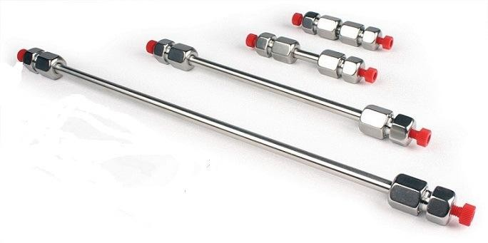

Columns with different length
Particle shape:
Most modern chromatographic packing materials are composed of spherical particles, although irregularly shaped particles are also available. Spherical particles are generally preferred because they produce lower back pressure and improve column durability,

especially when viscous mobile phases such as 50:50 methanol-water mixtures are used.
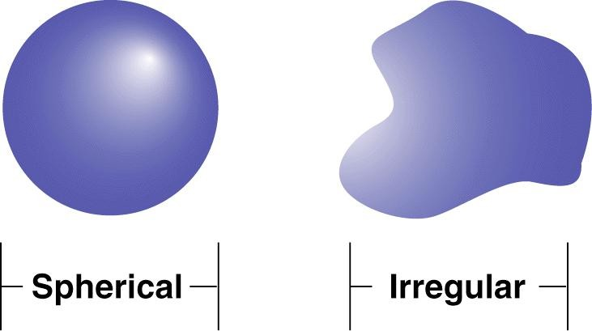

Particles with different shapes
Particle Size:
The size of the particles is the average diameter of the packing material in the column. Typical particle sizes are in the range of 3 µm (high efficiency separation) to 15-20 µm (preparative applications). A particle size of 5 µm is widely accepted as a good compromise for column efficiency while maintaining a reasonable back pressure. Smaller particles pack closer together and cause less sample diffusion and sharper, narrower peaks. They, however, also produce greater solvent pressure. Generally, particle sizes of For separating complex mixtures with multiple components 1.5 or 3 µm are preferred while 5 or 10 µm particles are suitable for routine analysis. Generally, particle sizes of
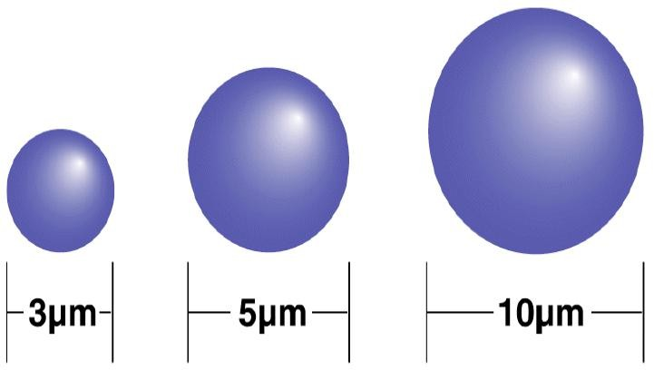

Particles with different diameters
Surface area
Surface area, expressed in m²/g, represents the total area available on both the outer surface and inside the pores of the packing particles. Columns with higher surface area generally provide stronger solute retention, better sample capacity, and improved


resolution. Because of these advantages, packing materials with high surface area are usually preferred for separating complex mixtures containing many components.

Different surface area particles
Pore size:
The mean diameter of the openings or cavities within the porous packing material is the pore size. The pore size is in the range of 60 Å to over 10,000 Å. The larger the pores the better they retain larger molecules and the higher the interaction that the analytes will have with the internal surface of the particles. Compounds having molecular weights of 2000 and below are best suited for columns with pore size of 150 Å or smaller, and molecular weights greater than 2000 are best suited for columns with a pore size of 300 Å or larger.


Particles with different pore size
Bonding Type:
The bonding method refers to the method used to couple the stationary phase to the base silica material. Monomeric bonding extends to a single point on each molecule of the bonded phase, while with polymeric bonding it is attached at more than one point. Typically, polymeric bonding results in higher column stability, especially when highly-aqueous mobile phases are employed. Also, it makes the column more robust to load of samples.
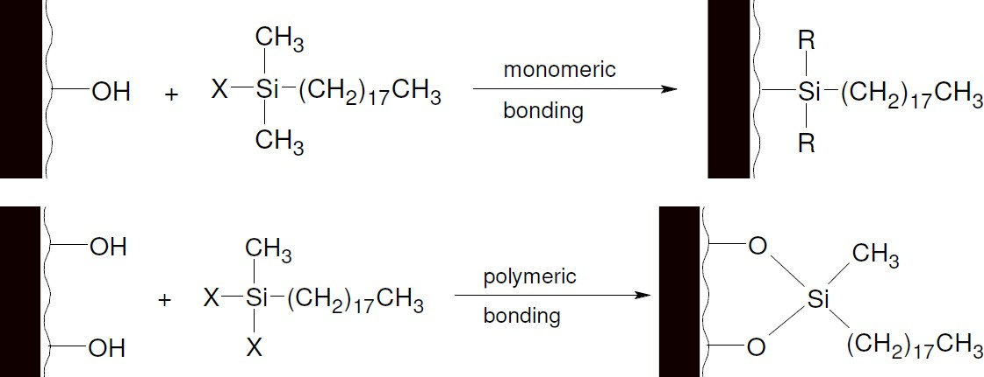

Monomeric and polymeric bonding
Carbon Load:
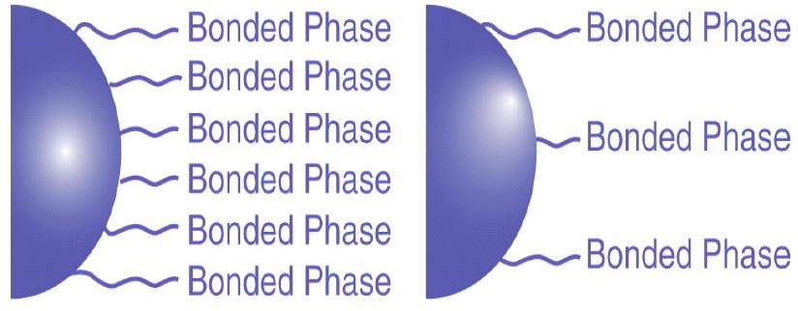
Carbon load indicates the amount of bonded stationary phase present on the base material. In columns such as C18, C8, and phenyl phases, carbon load strongly influences hydrophobic retention. Columns with higher carbon load usually provide greater retention, improved resolution, and higher sample capacity, although they may increase analysis time. Lower carbon load, on the other hand, reduces run time and may alter selectivity because more of the silica surface remains exposed. High carbon load columns are generally preferred for complex samples that require maximum separation, while lower carbon load columns are more suitable for simpler mixtures or samples requiring high water content for solubility and stability.

Carbon load

Endcapping:
Endcapping is a process used in reversed-phase chromatography in which small hydrocarbon groups are bonded to the remaining free silanol groups on the silica surface after the main bonded phase has been attached. This process helps reduce peak tailing caused by interactions between polar analytes and exposed acidic silanol groups. Non-

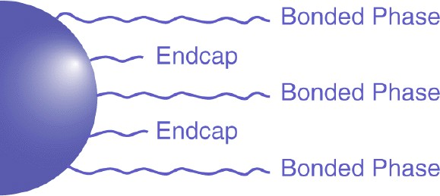
endcapped columns may provide different selectivity compared to endcapped columns, particularly when analyzing polar compounds.
In HPLC column selection, the bonded phase chemistry is selected based on the chemical nature of the sample components, while the physical properties of the column are chosen according to the objectives of the separation method. This approach helps in identifying the most suitable bonded phase and particle bed characteristics required to achieve effective separation.

Detectors

High-Performance Liquid Chromatography (HPLC) uses many types of detectors including but not limited to UV–Visible detectors, photodiode array (PDA) detectors, fluorescence detectors, conductivity detectors, refractive index detectors, electrochemical detectors, mass spectrometric detectors and evaporative light scattering detectors. Among these, the UV–Visible detectors are the most common one as they provide detection for a broad range of compounds.

pH Range
In order to obtain good chromatographic separation of analyte peaks, the pH range of the last method needs to be developed between 1 and 12. The separation is primarily based on efficiency, selectivity and retention time of the column. Changes in pH have a significant effect in these parameters since the analytes may be in acid form, basic form or both. Changing the pH of mobile phase may help to increase the retention time and separate ionized and non-ionized compounds. The ionization of the analytes and of the residual silanol groups on the silica surface is also affected by changes in pH, which decreases secondary interactions and can therefore lead to poor peak shapes. The mobile phase pH is then systematically changed, typically starting at low pH and increasing to pH higher than desired until a satisfactory separation is achieved.
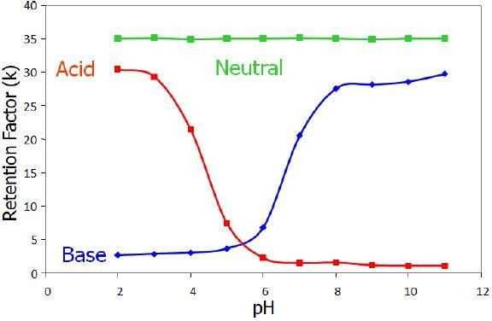

Correlation between retention factor and pH Mobile Phase Composition

The mobile phase, or solvent strength, in reversed-phase HPLC is a significant factor that affects separation. Among the most widely used solvents in RP-HPLC is acetonitrile (ACN; with a UV cut-off of 190 nm), methanol (MeOH; UV cut-off of 205 nm) and tetrahydrofuran (THF; UV cut-off of 212 nm). All of these solvents are water soluble. Of these, acetonitrile–water mixtures are often used as the starting point in the method development process because they will normally provide an efficient and reliable separation for a broad range of compounds.

Column Temperature
The temperature of the column is a major influence on the separation of chromatograms. The higher the column temperature, the lower the viscosity of the mobile phase, which will lead to a lower system back pressure and allow longer columns to be used for better separation efficiency. But with higher temperatures, some of the sample components may be less resolved. Thus, it is important to consider the nature of analytes being separated and adjust the optimum temperature accordingly. It is often possible to get better overall separation by varying both the column temperature and composition of the mobile phase. These days, normal-phase HPLC is making a comeback, with the emergence of hydrophilic interaction liquid chromatography (HILIC). This method provides better reproducibility for separating polar and hydrophilic compounds like peptides, carbohydrates, vitamins, polar drugs, and metabolites. Reliable method development results in better analytical performance and optimal HPLC method development mainly relies on proper optimization of the chromatographic conditions.
High- Performance Thin–Layer Chromatography (HPTLC) [20- 30] Pharmaceutical analysis is an essential part of the drug development process, making the availability of simple and rapid quality control methods very important for commercial formulations. High-performance thin-layer chromatography (HPTLC) is an important separation technique because it allows multiple samples to be analyzed simultaneously using only a small quantity of solvent. HPTLC is based on the same principle as thin-layer chromatography, where compounds are separated according to their different migration rates between two phases on specially designed plates. This technique is widely applied for both qualitative and quantitative analysis, including the identification and estimation of components present in mixtures

Steps involved in HPTLC
  - Preparation and activation of HPTLC plates
  - Sample preparation
  - Selection and preparation of mobile phase
  - Sample application on the plate
  - Chromatographic development of the plate
  - Drying of the developed plate
  - Detection/visualization of spots or bands
  - Densitometric scanning and documentation
  - Data analysis and interpretation
Selection of TLC/HPTLC plates and sorbent
Pre-coated plates with different support materials are available, in that aluminium support material is common. Usual thickness of 100 - 250 µm is used for qualitative and quantitative analysis. Generally, 80 % of analysis is carried out on silica gel other sorbent used are aluminium oxide, cellulose etc.
The commonly used pre-coated plates and their uses are listed below.

Sr. no. | Plate | Type of Analyte
1 | Silica gel 60 layers | Most of the drugs
2 | Reversed Phase Layers  (RP-2, RP-8, RP-18) | Lipids, Aromatics, Basic Drugs and Acidic analytes
3 | Cellulose and Keiselgurh | Amino acids and sugars
4 | Aluminium Oxide | Basic Drugs

Activation of Pre-coated Plates

Newly opened HPTLC plates usually do not require activation. However, if the plates have absorbed moisture due to exposure to humid conditions, they should be activated before use. This activation is commonly carried out by heating the plates in an oven at 110–120°C for approximately 30 minutes prior to sample application.

Preparation of sample

During normal-phase chromatography with silica gel or alumina-coated plates, sample solutions are typically prepared using non-polar, volatile solvents. In contrast, reverse-phase chromatography commonly employs polar solvents for dissolving the samples.

Sample Application

For HPTLC analysis, applying samples and standards in the range of 1.0–5.0 µL as bands generally provides better separation, uniform Rf values, and reduced spot broadening. Application of sample is commonly performed using a Linomat applicator, which ensures accurate, uniform, and reproducible spotting.

Pre-conditioning (Chamber Saturation)
Chamber saturation greatly influences chromatographic separation. Saturation is usually unnecessary for low-polarity mobile phases, but it becomes important when highly polar mobile phases are used. In reverse-phase chromatography, the chamber is generally saturated with methanol or another polar solvent before development.

Optimization of Mobile Phase
Selection of a suitable mobile phase is mainly carried out through trial and error. During this process, factors such as the chemical properties of the analyte and solvent, analyte solubility, interaction with the adsorbent layer, and practical experience of the analyst are considered.

Chromatographic Development
Various development techniques can be employed in HPTLC, including ascending, descending, horizontal, continuous, gradient, and multidimensional development methods. In most cases, a migration distance of approximately 5–6 cm is sufficient for effective separation on HPTLC plates. After completion of the development process, the plates are taken out of the chamber and dried to eliminate any remaining mobile phase.
Detection of Spots
In HPTLC, spots can be detected by visual observation under ultraviolet light at 254 nm using a UV chamber. Detection may also be carried out using iodine vapor in an iodine chamber.

Scanning and Documentation
Once the HPTLC plate development is completed, the plates are scanned at selected ultraviolet wavelengths using a suitable scanner. The separated spots are recorded on the computer as chromatographic peaks. The scanner transforms each band into a peak, and the peak height as well as peak area correspond to the amount of substance present in the sample. These values are measured by the instrument and documented quantitatively.

Factors Affecting TLC/HPTLC Separation and Spot Resolution
The quality of separation and spot resolution in TLC/HPTLC is influenced by several factors:
Nature and particle size of the stationary phase | Temperature and humidity during analysis
Composition and polarity of the mobile phase | Plate activation and moisture content
Thickness of the adsorbent layer | Solvent purity and quality
Sample concentration and volume applied | pH of the mobile phase
Method of sample application | Drying conditions after development
Chamber saturation conditions | Detection and visualization technique used
Development distance
High-performance liquid chromatography (HPLC) is another extensively used chromatographic technique for the analysis of bulk drugs, pharmaceutical formulations, and biological samples.
Spectrophotometric methods [31-34]
This method involves the measurement of amount of ultraviolet or visible radiations absorbed by substance in solution. The electromagnetic spectrum in the ultraviolet and visible region ranges from 100 to 780 nm and is classified into different regions based on wavelength. The quantitative analysis in spectrophotometry is mainly based on the Beer–Lambert law, which states that the, ‘When a beam of monochromatic light is passed through a transparent cell containing a solution of an absorbing substance, reduction of intensity of the light may occurs; the rate of reduction in intensity with the thickness of the medium is proportional to the intensity of the light and the concentration of the absorbing substances’.
Mathematically Beer- Lamberts law is expressed as:

A = a b c;
Where, A = absorbance or optical density.
a = absorptivity or extinction coefficient.
b = path length of radiation through sample (cm).
c = concentration of solute in solution.
The following techniques are commonly employed for the quantitative analysis of substances in single-component as well as multicomponent samples.
Simultaneous equation approach | Geometric correction approach
Multicomponent analysis method | Orthogonal polynomial technique
Least squares method | Difference spectrophotometric approach
Absorbance ratio technique | Derivative spectrophotometric technique

Derivative Spectrophotometric Method
Derivative spectrophotometry in the UV–Visible region is a valuable analytical technique used to obtain qualitative and quantitative information from overlapping spectral bands of analytes and interfering substances. With the help of computer- controlled instruments, this method has become highly useful for the simultaneous analysis of multicomponent mixtures using UV–Visible absorption spectrophotometry. In derivative spectrophotometry, the normal absorption spectrum is mathematically transformed into its first or higher-order derivative forms. This transformation improves the resolution between overlapping bands, minimizes interference from background signals or sample matrices, and produces more distinct spectral characteristics compared to conventional absorbance spectra. As a result, minor spectral details can be detected more effectively.

Area Under Curve Technique
The Area Under Curve (AUC) method is mainly used when sharp absorption peaks are not obtained or when the spectra are broad. In this technique, the integrated absorbance

between two selected wavelengths, λ₁ and λ₂, is measured. The instrument calculates the area enclosed between the spectral curve and the horizontal axis over the chosen wavelength range. The selected wavelength range is determined after repeated observations to ensure a linear relationship between the area under the curve and the analyte concentration. Spectra obtained from zero-order and first-order derivative methods are commonly used for AUC calculations. A calibration curve is then prepared by plotting concentration against the corresponding AUC values.

Validation of analytical method [34-38]
According to the United States Food and Drug Administration (USFDA), validation is defined as “the establishment of documented evidence that provides a high degree of assurance that a specific process will consistently produce a product that meets its pre- defined specifications and quality attributes.”
For analytical testing, method validation is an important step to ensure the performance of an analytical procedure for its intended use. This process guarantees reliable, accurate and consistent analytical information, required to ensure quality control of pharmaceutical products. It is important especially in regulated situations where there is a requirement for validated methods to prove compliance with the USFDA standards.
Validation of an analytical method is a series of systematic studies to establish the ability of the method to produce reliable and reproducible results. All regulatory submissions and routine quality control activities with pharmaceuticals, biologicals and medical devices require this validation.
The validation of an analytical method typically involves the evaluation of several key performance characteristics, including:
- Accuracy – The extent to which the results obtained by the analytical method agree with the true or accepted value.
- Precision – The closeness of agreement between repeated measurements performed under the same conditions on multiple samples.
- Specificity – The capability of the method to accurately measure the analyte in the presence of impurities, degradation products, or other sample components.
- Limit of Detection (LOD) – The minimum concentration of analyte that can be detected by the method, although it may not be quantified accurately.
- Limit of Quantitation (LOQ) – The lowest concentration of analyte that can be measured quantitatively with acceptable precision and accuracy.

- Linearity – The ability of the analytical method to produce results that are directly proportional to the concentration of analyte within a specified range.
- Ruggedness – The reproducibility of analytical results under varied normal conditions, such as changes in analysts, instruments, laboratories, or operating days.
- Robustness – The capacity of the method to remain reliable and unaffected by small intentional changes in analytical parameters during routine use.

Accuracy Definition:

A crucial factor in the validation of analytical methods is accuracy. It describes how closely the value derived from the analytical process agrees with the actual or recognized reference value. To put it another way, it shows how closely the test findings match the real concentration of the analyte in the sample. Accuracy also known as "trueness" is essential to guaranteeing that the process can produce accurate and trustworthy results.

Purpose:
The evaluation of accuracy ensures that the method provides correct and reliable results across a range of concentrations. It is especially important when a method is used to determine the potency or content of a drug substance or drug product.

Procedure:
Accuracy is typically assessed by analyzing samples containing known amounts of the analyte (i.e., standard spiked solutions) at multiple concentration levels often covering the lower, middle, and upper ranges of the method’s working range (e.g., 80%, 100%, and 120% of the nominal concentration). The results obtained are then compared with the theoretical (true) values.

Acceptance Criteria:
To meet regulatory expectations and ensure reliability of the method, the following acceptance criteria are generally applied:
- The percent recovery of the drug at each concentration level should fall within the range of 98.0% to 102.0%.
- The Relative Standard Deviation (RSD) at each level should be not more than 2.0%, indicating good precision in the measurement of accuracy.
- The overall average percent recovery (calculated from all levels) should also lie between 98.0% and 102.0%, with the overall % RSD not exceeding 2.0%.

The accuracy of an analytical method provides a strong indication of its capability to yield results that truly reflect the actual content of the analyte in the sample. Meeting the defined acceptance criteria ensures that the method is not only valid but also dependable for its intended use in quality control and regulatory compliance.

Precision Definition:
Precision refers to the degree of agreement or closeness between a series of individual measurements of the same homogeneous sample under specified conditions. It provides an indication of the repeatability or consistency of the analytical method. Precision is essential to demonstrate the reliability of the method when used repeatedly under the same or varying conditions.
Precision is typically evaluated at three different levels:

Repeatability (System Precision):
The closeness of agreement between successive measurements under the same operating conditions over a short interval of time by the same analyst using the same equipment.

Intermediate Precision (Ruggedness):
The variability within laboratories, determined by analyzing the same sample under different conditions such as different analysts, equipment, and days.

Reproducibility:
The precision between laboratories (inter-laboratory studies), usually applicable in collaborative studies and not always required in routine validation unless specified.

Purpose:
Evaluating precision is crucial for ensuring that the analytical method delivers consistent results within an acceptable range, regardless of small changes in test conditions. It confirms the method’s reliability in routine use.

Acceptance Criteria:
To comply with regulatory guidelines and ensure method suitability, the following acceptance criteria are applied:

System Precision:
  - Evaluated by multiple injections (usually six) of a standard solution.

  - The % Relative Standard Deviation (RSD) for the peak area of each analyte should be not more than 2.0%, or as specifically defined under the system suitability criteria in the analytical method.

Method Precision (Repeatability):
  - Assessed by preparing and analyzing six independent sample solutions under the same conditions.
  - The % RSD of the six assay results should be not more than 2.0%, demonstrating consistent performance of the method during normal operation.

Intermediate Precision (Ruggedness):
  - Conducted by analyzing six samples under varied conditions (e.g., different analysts, instruments, or days).
  - The % RSD of the six assay results should be not more than 2.0%.
  - Additionally, when results from method precision and intermediate precision are pooled, the overall % RSD should also be not more than 2.0%, indicating that the method is robust across varied operational conditions.
Precision assessment confirms the repeatability and consistency of an analytical method, ensuring that it can produce reliable results during routine analysis. Meeting the defined precision criteria is essential for regulatory compliance and quality assurance in pharmaceutical analysis.

Specificity Definition:
Specificity is defined as the ability of an analytical method to unequivocally assess the analyte in the presence of components that may be expected to be present in the sample matrix. These components may include impurities, degradants, excipients, or other potential interfering substances.
Specificity plays a vital role in:
- Identification tests: To ensure that the analytical method correctly identifies the analyte.
- Purity tests: To confirm that all potential impurities, such as related substances, heavy metals, or residual solvents, are accurately detected and quantified without interference.
- Assay tests: To guarantee that the method provides a true and accurate measurement of the analyte’s potency in the sample, unaffected by the presence of other components.

The ability of the method to distinguish the analyte from other substances is fundamental to ensure its suitability for its intended use, particularly in complex formulations or stability-indicating methods.

Purpose:
Specificity ensures that the analytical method is capable of providing accurate and reliable results by effectively isolating and quantifying the analyte without interference from other substances. This is especially important for evaluating the purity and potency of pharmaceutical substances and products.

Acceptance Criteria:
To ensure that the analytical method meets the required level of specificity, the following acceptance criteria are applied:

Blank and Placebo Interference:
  - When blank and placebo solutions are analyzed, no peaks should elute or interfere at the retention time of the analyte peak.
  - This confirms that excipients, solvents, or other formulation components do not contribute to the analyte signal.

Comparison with Spiked Samples:
  - Triplicate samples spiked with known impurities are analyzed and compared with the results of the method precision study.

The difference between the mean result of spiked samples and the mean result from method precision should be not more than 2.0%.
  - This ensures that the method can distinguish between the analyte and impurities without compromising the accuracy.

Peak Purity Assessment:
  - The peak purity of the analyte peak(s) in spiked samples should be verified using a diode array detector or equivalent system.
  - The analyte peak must pass the purity criteria, confirming that it is not co- eluting with other compounds and is spectrally homogeneous.
Specificity is an essential characteristic of a validated analytical method, particularly for assays and impurity testing. A method that meets specificity requirements ensures the accurate identification, quantification, and purity assessment of the analyte, which is critical for quality control and regulatory compliance in pharmaceutical analysis.

Sensitivity [Limit of Detection (LOD) and Limit of Quantitation (LOQ)]

Definition:
The Limit of Detection (LOD) is defined as the lowest amount of analyte in a sample that can be detected by the analytical method, but not necessarily quantified as an exact value. It represents the point at which the presence of the analyte can be reliably distinguished from background noise, though precise numerical measurement is not feasible.
The Limit of Quantitation (LOQ), on the other hand, is the lowest amount of analyte that can be quantitatively determined with acceptable precision and accuracy. It marks the minimum concentration at which the analyte can not only be detected but also reliably measured.

Purpose:
LOD and LOQ are important parameters in method validation, especially for impurity profiling, trace analysis, and stability-indicating methods. These limits determine the sensitivity of the method and ensure that even small amounts of analyte or impurity can be accurately identified and quantified, where applicable.

Calculation:
LOD and LOQ are typically calculated using the signal-to-noise approach or based on the standard deviation of the response and the slope of the calibration curve, as recommended by ICH guidelines.
In this method, the following equations are applied:

LOD = 3.3 × (N / B)
- LOQ = 10 × (N / B)
Where:
- N = Standard deviation of the response (e.g., peak area of the analyte)
- B = Slope of the calibration curve (derived from linearity studies)
These calculations help to define the smallest concentrations of analyte that can be reliably detected (LOD) and quantified (LOQ) by the method under validation.
Determining the LOD and LOQ is essential for evaluating the sensitivity and performance of an analytical method. Ensuring that these parameters are established and meet expected criteria supports the method’s capability to detect and quantify low levels of analyte or impurities, contributing to overall method reliability and regulatory compliance.

Linearity Definition:

Linearity refers to the ability of an analytical procedure to produce test results that are directly proportional to the concentration of analyte within a specified range. It confirms that the analytical response (e.g., peak area or absorbance) increases or decreases in a linear fashion with increasing or decreasing analyte concentration.
Linearity is fundamental to ensuring that the method can accurately and consistently quantify the analyte across the range of concentrations expected in routine analysis.

Purpose:
The purpose of evaluating linearity is to demonstrate that the analytical method provides results that are both accurate and reliable across the working range. It is especially critical for assays, content uniformity testing, and quantitative impurity analysis.

Procedure:
Linearity is assessed by preparing and analyzing a minimum of five different concentrations of the analyte, typically spanning from 80% to 120% (or broader, as required) of the target concentration. The analytical response is plotted against concentration to generate a calibration curve.
The relationship is evaluated using regression analysis, where key statistical parameters such as the correlation coefficient (r), slope, and y-intercept are determined.

Acceptance Criteria:
- The correlation coefficient (r) for the calibration curve should be not less than 0.999, indicating an excellent linear relationship between analyte concentration and response.
- Additionally, residuals (difference between observed and predicted values) should be minimal, and the curve should not show significant curvature or deviation from linearity.
Linearity assessment ensures that the analytical method can reliably measure the analyte concentration within the specified range. A correlation coefficient of ≥0.999 confirms the method’s suitability for quantitative analysis and supports its application in routine quality control and regulatory submissions.

Ruggedness Definition:
Ruggedness refers to the degree of reproducibility of test results when the same sample is analyzed under varied operating conditions. These variations can include different analysts, different laboratories, different instruments, different reagent lots,

and different days. Ruggedness is also often referred to as intermediate precision and reflects the method’s robustness and reliability under normal usage conditions.
This parameter is essential to demonstrate that the analytical method performs consistently across different operational environments, making it suitable for routine use in quality control settings.

Purpose:
The evaluation of ruggedness ensures that minor and deliberate variations in testing conditions do not significantly affect the test results. It highlights the method’s reliability and confirms its suitability for widespread and consistent application in different laboratories and by different users.

Procedure:
Ruggedness is typically assessed by analyzing the same sample multiple times (commonly six replicates) under varying conditions such as:
- Different analysts
- Different instruments
- Different days
- Different lots of reagents or columns
The results are then compared to assess the variability introduced by these factors.

Acceptance Criteria:
- The overall Relative Standard Deviation (% RSD) of the assay results obtained under varied conditions should be not more than 2.0%.
- This indicates that the method maintains precision and consistency even when slight variations in operating conditions are introduced.
Ruggedness is a vital component of method validation that demonstrates the reproducibility and reliability of the analytical procedure under realistic, variable laboratory conditions. Meeting the ruggedness criteria ensures that the method is dependable for routine analysis across different users, instruments, and environments, thereby supporting regulatory compliance and product quality assurance.

Robustness Definition:
Robustness is defined as the ability of an analytical procedure to remain unaffected by small but deliberate variations in method parameters. It provides a measure of the method’s reliability and consistency under normal, routine usage conditions.

Evaluating robustness helps to identify factors that may influence method performance and ensures the method’s suitability for use over time.

Purpose:
The purpose of robustness testing is to demonstrate that the analytical method is stable and reliable, even when minor adjustments or variations are introduced. This is crucial in ensuring consistent analytical performance during routine operations, manufacturing scale-up, and across different laboratories.

Procedure:
Robustness is typically assessed by introducing small, controlled changes to method parameters such as:
- Flow rate (± 0.1 mL/min)

Mobile phase composition (± 2%)
- Column temperature (± 5°C)
- pH of mobile phase (± 0.1 units)
- Detection wavelength (± 2 nm)
The impact of these changes is evaluated by analyzing the same sample under each condition and comparing the results.

Acceptance Criteria:
- The overall Relative Standard Deviation (% RSD) of the results obtained under these varied conditions should be not more than 2.0%.
- This confirms that the method retains its precision and accuracy despite small fluctuations in testing parameters.
Robustness testing is a key component of method validation that confirms the stability and dependability of an analytical method. By ensuring that small, deliberate changes in analytical parameters do not significantly affect the outcome, robustness testing validates the method’s capability for consistent performance under routine laboratory conditions.

System suitability testing Definition:
System Suitability Testing (SST) is a critical component of chromatographic method validation, particularly for High-Performance Liquid Chromatography (HPLC) and Gas Chromatography (GC) techniques. It is conducted to ensure that the

chromatographic system performs consistently and meets the necessary quality standards prior to or during the analysis of samples.
SST provides assurance that the analytical system is functioning properly and is capable of producing results with the required accuracy, precision, and resolution. It is typically performed using a standard solution prior to sample analysis.

Key Parameters for System Suitability Testing
Each SST parameter provides insights into specific aspects of system performance. The following metrics are commonly evaluated:

Capacity factor (K')
K' = ( tR– to) /to
Where, tR = is the band retention time tO = is the column dead time
The capacity factor is a measure of where the peak of interest is located with respect to the void volume, i.e., elution time of the non-retained components. K' indicates its retention behavior in a column. Small values of k' indicates that compound is poorly retained and eluted near the void volume. Large value of k' indicates that good separation but have longer analysis time with peak broadening and decrease in sensitivity.
Recommendation: The peak should be well-resolved from other peaks and the void volume, generally k’ > 2.0

Tailing factor (T) T = W 0.05 / 2F
W0.05:- Width of peak at 5% height. And F is leading edge of peak
T: Distance from the peak maximum to the leading edge of the peak height from the baseline It is a measure of max symmetry, and is 1 for perfectly symmetrical peaks and increases as the tailing becomes more pronounced. Increased tailing of a peak leads to lower accuracy of quantitation.

Recommendation: T must be ≤ 2

Theoretical plates (N)
A chromatographic column is divided into N theoretical plates. A thermodynamic equilibrium of the analytes between the mobile and stationary phase occurs within each plate. The efficiency of the column is thus expressed as the number of theoretical plates. N is determined experimentally from a chromatogram using the equation:
N = 16 (tr/W) 2
Where‘t’ is the retention time and ‘W’ is the width at the base of the peak.
Recommendation: N should be > 2000.

Precision/Injection repeatability (RSD)
Injection precision, expressed as relative standard deviation (RSD), reflects the overall performance of the chromatographic system, including the plumbing, column efficiency, and environmental conditions during sample analysis. It should be noted that sample preparation and manufacturing variations are not considered.
Recommendation: RSD of 1 % for n = 5 is desirable.

Resolution (Rs)
Rs = 2 (t2 – t1) /W1+W2
Here, t1 and t2 are the retention times
W1 and w2 are baseline bandwidths
Resolution provides a quantitative measure of ability of the column to separate the 2 analytes. This measurement is obtained by retention time and peak width which is easily obtained from the chromatogram. For two peaks to be recognized as separate the resolution should be at least 0.5. Two peaks are seen as completely separate if R is greater than 2. The resolution can be improved by lengthening the column but this will also increase the analysis time.
Recommendation: Rs greater than 2 between the peak of interest and the closest eluting possible interference (impurity, excipient, degradation product, internal standard, etc.).

DRUG PROFILE:

Lenalidomide [39 - 43] Structure:
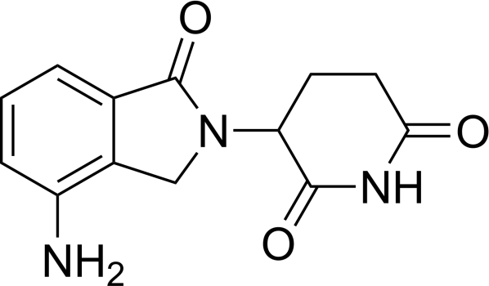

Molecular Formula | : C13H13N3O3
Molecular Weight | : 259.26 g/mol
Chemical Name | : 3-(7-amino-3-oxo-1H-isoindol-2-yl)piperidine-2,6- dione
Description | : Off-white to pale-yellow solid powder
Solubility | : Soluble in organic solvent/water mixtures and buffered aqueous solvents. It is more soluble in  organic solvents and low pH solutions.
Melting Point | : 265-270 ℃
Dose | : 10 mg
Category | : Immunomodulatory imide drugs (IMiDs)
pKa | : 4.7
Mechanism of Action | : - Immunomodulation (↑ T-cell & NK activity)  - Anti-angiogenesis

- Direct anti-tumor effect
- Cereblon-mediated protein degradation
Pharmacokinetics | : Absorption: Rapid (Tmax 0.6–1.5 h) Bioavailability: High  Distribution: 30% protein bound Metabolism: Minimal  Excretion: Primarily renal (unchanged)  Half-life: ~3–5 h
Therapeutic Indications | : - Multiple Myeloma  - MDS with del(5q)  - Mantle Cell Lymphoma  - Follicular & Marginal Zone Lymphoma (selected cases)
Dosage & Administration | : Typically 25 mg once daily for 21 days of a 28-day cycle (varies by indication); dose adjusted in renal  impairment
Adverse Effects | : - Neutropenia, thrombocytopenia  - Fatigue, diarrhea  - Rash, pruritus  - DVT, hepatotoxicity  - Teratogenicity
Contraindications | - Pregnancy (Category X)  - Hypersensitivity to lenalidomide
Black Box Warnings | : - Severe birth defects (strict pregnancy prevention required)  - Blood disorders  - Thromboembolism risk
Drug Interactions | Limited due to minimal CYP involvement; caution  with myelosuppressive agents or thrombotic risk enhancers
Storage Conditions | : 25°C (77°F); excursions to 15–30°C allowed; store in  original packaging

Literature survey revealed that few analytical methods were reported for the determination of Lenalidomide in bulk, biological fluid, and pharmaceutical formulation. The detailed account of these methods is as follows
Analytical Method for Determination of Lenalidomide

Development and validation of stability-indicating UHPLC-UV-MS tandem methods for lenalidomide assay, related substances, and genotoxic impurity monitoring [44]
The immunomodulatory agent lenalidomide is a powerful immunomodulatory agent that is used in the treatment of MDS. To get an understanding of the degradation behavior under stress and stability testing conditions a novel ultra-performance liquid chromatography (UHPLC)-UV-MS tandem method with high specificity, precision, accuracy, and robustness was designed and validated. Lenalidomide was profiled and quantified for its impurities by UPLC, using an Acquity UPLC Phenyl column (100 x 2.1 mm x 1.7 µm) with a column temperature of 30 °C, a sample temperature of 15 °C and an injection volume of 1.0 µL at 254 nm. Diluent: 0.1 % formic acid and acetonitrile (90:10, v/v); Mobile Phase A: 0.1 % formic acid; and Mobile Phase B: acetonitrile. Impurity analysis was conducted in 20 min gradient with 0.2 mL min-1 flow rate and the assay determination was done in 7 min gradient with 0.3 mL min-1 flow rate. This method was found to be good linear for all analytes and they can be quantified accurately. Stress and photostability studies showed that lenalidomide was stable when exposed to hot conditions (105 °C for 10 days) and to daylight/UV conditions, but showed a high degree of degradation when exposed to hydrolytic and oxidative conditions. The major degradation products A, B and E were obtained under hydrolysis conditions, and the impurities C (conversion of –NH2 to –NO2) and I (conversion of –NH2 to – NH–OH) were obtained under oxidative stress conditions. Methanol, which is frequently employed in the synthesis of lenalidomide as well as analytical work, was identified as a key reaction component in the formation of impurities. The glutarimide ring-opening products J and K were suggested as constitutional isomers, and confirmed by UHPLC-Q-TOF-MS and NMR analysis. It was also successfully used to monitor the impurity G that was identified as a potentially genotoxic impurity (PGI) by the ICH M7 guidance, thus allowing the impurity to be kept below the Toxicological Threshold Concern (TTC = 1.5µg/day, 60ppm) with regard to patient safety, as required by the health authority. This comprehensive analytical study renders time-dependent stability and safety of lenalidomide assured and provides hints towards degradation pathways. The results help to develop better impurity control strategies, optimize manufacturing processes and meet regulatory requirements for the entire class of drug substances that contain glutarimides like pomalidomide and thalidomide.

Estimation of Lenalidomide in Bulk and Its Dosage Form Using UV Spectrophotometric and RP-HPLC Methods [45]
The present study involved the development of simple, economical, rapid, accurate, and precise UV spectrophotometric and isocratic RP-HPLC methods for the estimation of Lenalidomide in bulk drug and pharmaceutical formulation. The analysis was carried out at 250 nm that was found to be λmax by UV spectrophotometer. A reverse-phase C18 Waters column (4.6 mm X 250 mm, 5 μm) was used for the RP-HPLC procedures. The mobile phase was prepared by mixing 20 mM acetate buffer (pH 5) and methanol in 85:15 ratio which was pumped at a flow rate of 1 mL per min. Additionally, detection was carried out at 250 nm. The developed procedures were successfully validated following ICH Q2 (R1) guidelines. The developed RP-HPLC and UV spectrophotometric methods were found to have an excellent linearity with correlation coefficient (r2) value of 0.998 and 0.9986. Percentage relative standard deviation for both the approaches was found to be less than 2%. This suggests that both the methods are highly precise. The average percentage recovery was calculated to be about 99.2% and 99.6% for the UV and RP-HPLC method respectively. Both the methods were found to be robust, selective and specific for routine analysis of Lenalidomide capsule based on the data obtained.
Investigation of the Chemical Stability of Lenalidomide in Methanol/Ethanol Solvents Using RP-HPLC-UV and LC-MS [46]
Lenalidomide is a heterocyclic drug used for the treatment of Myelodysplastic syndrome. The current research focuses on the structural elucidation of new degradants that are formed unexpectedly upon storage of lenalidomide in methanol, followed by proposing their corresponding formation mechanism. The proposed structures of the degradants are relatively stable in which two tetrahedral intermediates result from nucleophilic addition of methanol to the carbon of the carbonyl group of the imide ring. Methanol molecules, as a solvent, may contribute in stabilizing the intermediate via hydrogen bond formation with it. These degradants

were found to be abundant in lenalidomide/ methanol solution. Hence, the toxicological evaluation of them is crucial.

In vitro DNA binding studies of lenalidomide using spectroscopic in combination with molecular docking techniques [47]
In the present work, the interaction between lenalidomide (LEN) with calf thymus DNA (ct-DNA) was systematically studied by using fluorescence, ultraviolet-visible (UV-vis) absorption, circular dichroism (CD) spectroscopies under imitated physiological conditions (pH = 7.4) coupled with molecular docking. It was found that LEN was bound to ct-DNA with high binding affinity (Ka = 2.308 × 105 M−1 at 283 K) through groove binding as evidenced by a slight decrease in the absorption intensity in combination with CD spectra. Thermodynamic parameters (ΔG < 0, ΔH > 0, and ΔS < 0) of the LEN-DNA system were obtained at three different temperatures, suggesting that the binding process was spontaneous and was primarily driven by hydrogen bonds and hydrophobic interactions. Furthermore, competitive binding experiments with ethidium bromide and 4′, 6-diamidino-2-phenylindole probes indicated that LEN could preferentially bind in the minor groove of double-stranded DNA. The average lifetime of LEN was calculated as 7.645 ns. The φ of LEN was measured as 0.09, and non- radiation energy transfer between LEN and DNA had taken place. The results of the molecular docking were consistent with the experimental results. This study explored the potential applicability of the spectroscopic properties of LEN and also investigated its interactions with relevant biological targets. In addition, it will provide some theoretical references for the in-depth research of the simultaneous administration of LEN with other drugs.

Lenalidomide‐induced psoriasis in a refractory multiple myeloma patient successfully treated with narrowband Ultraviolet B [48]
This article discusses a case study of a patient with refractory multiple myeloma who developed psoriasis as a side effect of lenalidomide treatment. The patient was successfully treated with narrowband ultraviolet B phototherapy (NB-UVB) without discontinuing the lenalidomide. The article highlights the efficacy and safety of NB- UVB in managing lenalidomide-induced psoriasis and suggests that NB-UVB can be

considered as a therapeutic option for psoriasis secondary to anti-multiple myeloma agents. However, further validation through larger prospective trials is needed.

Development of a Rapid and Sensitive HPLC Assay Method for Lenalidomide Capsules and Its Related Substances [49]
A chromatographic method was established for the determination of lenalidomide and related substances in 10 mg and 5 mg capsules using Sunfire C-18(250×4.6 mm ID, 5 μm) HPCL column with 85:15 v/v ratio of mobile phases A (mixture of phosphoric acid buffer and 1-octane sulphonic acid sodium salt) and B(55: 45 v/v ratio of methanol and acetonitrile) at 40°C and 210 nm wave length. 0.1 N HCl, 0.1 N NaOH, 1% v/v hydrogen peroxide, humidity, UV radiation at 254 nm, sunlight, and heating at 60°C were used in the degradation investigations. Although there was some minor deterioration in alkaline conditions with NaOH, lenalidomide did not exhibit significant degradation in the majority of stress conditions. The method's appropriateness for stability investigations was confirmed by the developed HPLC method, which showed peak purity angles below the threshold values. For metrics including linearity, accuracy, precision, ruggedness, and resilience, the approach was satisfactorily validated.
Development of an HPLC Assay Method for Lenalidomide [50]
Chromatographic separation of lenalidomide and its impurities was achieved on an Inertsil ODS-3 V column using a mobile phase consisting of a mixture of buffer, acetonitrile and methanol in the ratio 80:8:12 v/v. Using 0.5 N hydrochloric acid, 0.5 N sodium hydroxide, 10% v/v hydrogen peroxide, 60 °C, and UV radiation at 254 nm, additional stability experiments on the degradation of bulk lenalidomide samples were conducted [20source]. Only under typical hydrolysis conditions was significant deterioration observed. A mass balance value of almost 99.5% was obtained using the established LC method, demonstrating the suitability of the produced stability indicating LC method. Linearity, accuracy, and precision of the method was validated as well.
Stability Indicating RP-HPLC Method for Quantitative Estimation of Lenalidomide and Its Impurities in Solid Dosage Form [51]
The main aim and objectives of the research are to develop an effective, sensitive, economical, and simple reverse-phase HPLC method for determining and quantifying Lenalidomide impurities in Lenalidomide solid dosage formulations. The lack of research work and no compendial methods available for estimating this drug influenced the current research investigation to give a simple, sensitive, rapid, precise,
accurate and robust gradient high-performance liquid chromatographic method for the determination and quantification of Lenalidomide and its impurities. Reverse phase (RP-HPLC) is used to examine samples. The stationary phase is an Inertsil ODS-3V (150 x 4.6 mm, 3µm), and the mobile phase is made up of two channels: channel-A is pH 3.0 phosphate buffer, and channel-B is acetonitrile: water (90:10 v/v) in the gradient elution proportion. 1.0 mL/min is the flow rate. The injection volume was 20 µL, the wavelength was 210 nm, the column temperature was kept at 40°C, and the sample cooler temperature was kept at 5°C. The chromatograms for blank, placebo, standard, sample, and spiked sample solutions of lenalidomide and related chemicals were recorded, and the devised HPLC technique was validated with respect to specificity. Specificity studies reveal that the peaks are well separated from each other. For precision, the results were found to be within acceptable limits. The limits of detection (LOD) and quantitation (LOQ) for Impurity-A are 0.1124 µg/mL and 0.0371 µg/mL, respectively, whereas those for Impurity-B are 0.2247 µg/mL and 0.0742 µg/mL. With a correlation coefficient higher than 0.99, the linearity results for Lenalidomide and every impurity within the designated concentration range are good. The accuracy studies were shown as % recovery for Lenalidomide and its impurities at the specification level; the results obtained were within limits. Solution stability parameter was established; standard, sample, and spiked sample solutions are stable up to 48 hrs on a bench top at the refrigerator. Filter validation parameters were established, and the filtered spiked sample solutions are compatible with both 0.45 µm PVDF & 0.45 µm Nylon filters.

Method development and validation of degradation studies of lenalidomide by RP-HPLC [52]

A simple and accurate RP-HPLC method was developed for the estimation of lenalidomide. The analysis was carried out using Shimadzu LC-2010 HT RP-HPLC instrument. Separation was achieved using shim-pack C18 column (250 × 4,6 mm, 5 µm) maintained at 25 oC and a mixture of phosphate buffer and acetonitrile (55:45 v/v) as a mobile phase. The flow rate was 1 ml/min and UV-visible detector was set at 242 nm. The retention time of lenalidomide was found to be 2.5 min. Theoretical plate number and tailing factor for lenalidomide were found to be 16199.817 and 1.128 respectively which are within the acceptance criteria.

For linearity, accuracy, precision, robustness and system suitability parameters the developed method was validated.

As for the limit of detection (LOD) and limit of quantification (LOQ), they were found to be 0.058 μg/mL and 0.174 μg/mL respectively. The calibration curve was linear over the ΔA concentration range of 25-150 μg/mL with regression equation Y=5223x+183075. Recovery studies verified the method's accuracy. The retention time developed was shorter than previously reported methods. Thus the validation results confirmed simplicity, rapidity, precision and accuracy of the RP-HPLC method making it suitable for routine analysis of lenalidomide from bulk drug substances and pharmaceutical dosage forms.

New Spectrophotometric Methods for Estimation of Lenalidomide in Pharmaceutical Formulations [53]
Two simple and sensitive spectrophotometric methods (Method A and Method B) have been developed for the estimation of Lenalidomide in pharmaceutical formulations. Method A was based on diazo-coupling reaction with N-(1-napthyl) ethylenediamine dihydrochloride (B.M. reagent) to form a stable purple coloured chromogen which could be estimated at 540 nm. Method B was based on the formation of a coloured condensation product with the aromatic aldehyde, namely, p-dimethyl amino cinnamaldehyde (PDAC) which showed absorption maximum at 530 nm. In the concentration range of 1 to 5µg/ml both of the suggested procedures (Method A and Method B) followed Beer's law. The techniques were approved for routine Lenalidomide quality control of pharmaceutical formulations.

Development of a reversed-phase HPLC method for determination of related impurities of Lenalidomide [54]
In this project, we have developed a method of reversed-phase liquid chromatography for the separation and determination of lenalidomide (LENA) and related substances using a C-8 (250×4.6 mm ID, 5 μm) HPCL column. The mobile phases used in the study were phosphate buffer at pH 3.30 as mobile phase A and a mixture of methanol and acetonitrile (1:5 v/v) as mobile phase B. Chromatographic analysis was carried out at a column temperature of 25°C with detection at 220 nm, and a sample injection volume of 20 µL was used. The stress degradation studies were performed under acidic, basic, oxidative, and thermal conditions. Significant degradation of lenalidomide was observed when subjected to alkaline stress.
The study results showed good peak resolution for fresh sample, acidic stress and thermal stress conditions. In case of thermal degradation, the resolution values between adjacent peaks were found to be 3.6, 3.2, 5.3 and 4.7 respectively. This shows that the developed method gives satisfactory separation and resolution of the degradation products formed during thermal stress conditions.

Development, validation, and greenness assessment of environmentally friendly analytical methods for the quantification of lenalidomide in pharmaceutical formulations [55]
Lenalidomide is described as having immunomodulatory, anti-angiogenic and anti-inflammatory properties. In this work, green HPLC and spectrophotometric methods were developed and validated for the quantitative analysis of lenalidomide in pure and pharmaceutical formulations. In the HPLC method, a mixture of 10 mM potassium dihydrogen phosphate solution (pH: 2.0) and ethanol (50:50, V/V) was used as mobile phase, isocratic elution at a flow rate of 1.0 mL min −1 and a UV detector at 304 nm. The spectrophotometric method was based on a complete analysis of the spectral patterns of standard solutions in different solvents; the best spectra were obtained using ultrapure water as a solvent and a wavelength of 304 nm was chosen for the measurements. Both methods were validated according to ICH guidelines for several parameters. Correlation coefficients higher than 0.999 were calculated for both methods for the concentration range of 5–30 μg mL −1 . The developed methods were applied to commercial formulations and the results were compared using the student (t) test for means and the Fisher (F) test for standard deviations. No significant difference was observed between the methods. The greenness evaluation of the methods was carried out using AGREE software. The developed methods are proposed as an excellent environmental and operator-friendly alternative for the quantification of Lenalidomide in pharmaceutical formulations.

Simultaneous determination of thirteen related substances in lenalidomide API by a stability-indicating RP-HPLC method [56]
The purpose of the study was to develop a suitable HPLC method for the separation and determination of related impurities and potential genotoxic impurities in lenalidomide API. Using pH 4.0 phosphate buffer-acetonitrile gradient as a mobile phase for chromatographic separation, the analysis of lenalidomide was performed. The separation was achieved on a Zorbax SB-AQ column (250 mm×4.6 mm, 5μm) with a wavelength of 220 nm. The results of method validation revealed that the described approach is specific, linear, accurate, repeatable, and robust.
The limit of detection ranged from 2-17ng/mL while the limit of quantification ranged from 6-50ng/mL. For the calibration procedure, a direct linear regression of lenalidomide and impurities peak area (mg/ ml) was applied using eight concentrations. The regression coefficient was found to be r≥0.999. The oxidation and base degradation products of lenalidomide were identified with the confirmation of their chemical structures. A single analytical procedure was developed for the qualitative and quantitative analysis of thirteen related substances in lenalidomide API. The method can be used in routine laboratory testing for assay or quality control purposes.

A Validated Stability-Indicating and Stereoselective HPLC Method for the Determination of Lenalidomide Enantiomers in Bulk Form and Capsules [57]
A rapid, stability-indicating and simple chiral HPLC method was developed for the separation of lenalidomide (LDM) enantiomers in the presence of degradation products. Drug subjected to significant pressure conditions in order to study its availability and separation of the degradation products and pure drug was precisely analyzed for enantiomers. The separation was achieved on a LUX 5U cellulose-2 chiral column (250 × 4.6 mm i.d.) with methanol, glacial acetic acid, and triethylamine (100:0.01:0.01; v/v/v) at a flow rate of 1.2 mL/min as the mobile phase. The internal standard was Ornidazole and the detection was accomplished at 220 nm. The presented method was evaluated for specific analytical genres. Stability, limit of detection, quantification, specificity, linearity, precision and accuracy, and resilience in the solution parameters were assessed. The calibration curve exhibited good linearity (2–1000 ng/mL range) for each of the enantiomers with correlation coefficient 0.9999 Validation of the method was achieved according to ICH and FDA requirements and was successfully utilized in the investigation of lenalidomide in both bulk drug and capsule formulations. The assay results indicated they were quite accurate for detecting the presence of protein and precision, with label claim values of 100.09 ± 0.80% for both the S-(−) enantiomer and OR: 99.97 for R-(+) enantiomer + x-0±0·93% These results mean that method is less RPTLC is reliable and suitable for routine quality control and stability studies of lenalidomide.

Degradation Studies of Highly Potent and Life-Threatening Human Birth Defect Drug Lenalidomide By HPLC and LC-MS [58]
Due to the potential of toxicity lenalidomide is a highly potent and severe life- threatening human birth defect drug. A lot of precaution should to be taken in handling such kind of drugs. The lenalidomide drug–excipient blend obtained from the capsule dosage form was exposed to various stress conditions recommended by ICH guidelines e.g. thermal stress, hydrolysis under different pH conditions, oxidation and photolysis. The drug remained stable under thermal and photolytic conditions but showed significant susceptibility to other stress conditions. To establish a stability-indicating method; the degradation of the drug solutions that have different degradation products were monitored at various time intervals using different concentrations of stressing agents. The optimization of chromatographic was achieved by modifying the LC conditions. A multi-step gradient elution method using an ACE® C18 stainless steel analytical column (150 × 4.6 mm i.d., 3 μm) provided satisfactory separation. Chromatographic analysis was performed using a mobile phase consisting of 0.01 M phosphate buffer (pH = 2.0 ± 0.1) (mobile phase A) one side and a mixture of water–acetonitrile in a ratio of 200:800 (v/v) (mobile phase B). The mobile phase was delivered at 1.0 mL min⁻¹ and detection was performed at 220 nm. The significant degradation products were found at relative retention times (RRT) of 0.75, 0.86, 0.96, 1.33, 1.52, 1.99, 2.04, 2.62 and 2.66 respectively.
Stability-Indicating Capillary Electrophoresis Method with Photodiode Array Detector for Determination of Lenalidomide in Pharmaceutical Preparation [59] In this study, metoclopramide was used as the internal standard. For electrophoretic separation at 22 °C, a deactivated fused silica capillary with an effective length of 52 cm and an inner diameter of 75 µm was used (background electrolyte: phosphate buffer solution (20 mM, pH 7.1) and methanol (90:10, v/v)). Samples were injected from the anodic side for 25 seconds at a back pressure of 20 mbar, and 30 kV was applied during the separation process. This was done by performing detection at 210 nm. Lenalidomide (LEN) was subjected to a variety of accelerated stress conditions and degradation products were separated from the intact drug, owing to their migration times. The limit of detection (LOD) was determined as 0.25 μg/mL and the limit of quantification (LOQ) as 0.80 μg/mL. The developed method was found to be precise (RSD ≤ 0.59) in intra-day and inter-day studies. Recovery studies were performed to evaluate the accuracy and values obtained were found to be within the range of 98.53% -100.80%. The method was successfully employed to determine LEN in bulk drug and capsule dosage form and produced value of assay 99.52 ± 0.43% of the labeled claim. These results indicate that the developed method is specific, accurate, precise, robust and suitable for estimating the quality and stability of LEN during routine analysis.
Development and Validation of Stability Indicating RP-HPLC Method for Quantitative Estimation of Lenalidomide in Lenalidomide Capsules Dosage Form [60]
A sensitive reverse phase (RP-HPLC) method was developed for the determination of Lenalidomide in Lenalidomide capsules dosage formulations. The samples are subjected to analysis by reverse phase high performance liquid chromatography. A C18 column Kromasil (150×4.6 mm, 5μm) and mobile phase of pH 2.5 phosphate buffer and acetonitrile in the ratio (90:10 v/v), flow rate 1.0 mL/min, column temperature 30°C, sample cooler temperature 5°C, injection volume 10 μL and wavelength 210 nm were used for the analysis. The new HPLC method was validated for its specificity, precision, linearity accuracy, solution stability and filter analysis according to ICH guidelines.
Degradation Studies of Highly Potent and Life-Threatening Human Birth Defect Drug Lenalidomide by HPLC and LLC-MS [61]
The drug–excipient blend of lenalidomide capsules was subjected to various stress conditions suggested by ICH guidelines including thermal stress, hydrolysis in different pH conditions, oxidation, and photolysis. The drug was stable to thermal and photolytic conditions while showed significant degradation under other stress conditions and extensive degradation was observed when the drug was exposed to alkaline medium. The degradation behavior of lenalidomide was examined at different time intervals by using different concentrations of stress-inducing reagents and a stability-indicating method was developed. The chromatographic conditions for analysis were optimized in order to obtain proper resolution of degradation peaks. An elution process was carried out by using a multi-step gradient approach on an ACE® C18 analytical column (150 × 4.6 mm i.d., 3 μm) to achieve an active separation of components. Mobile phases A and B were 0.01 M phosphate buffer (pH 2.0 ± 0.1) and a 200:800 v/v combination of water and acetonitrile, respectively. Analysis was carried out by using a detection wavelength of 220 nm and a flow rate of 1.0 mL/min. Relative retention durations (RRT) of 0.75, 0.86, 0.96, 1.33, 1.52, 1.99, 2.04, 2.62 and 2.66 were found for the principal degradation products which indicated that degradation impurities were successfully separated from the primary drug peak.

Method Development and Validation for the Quantitative Estimation of Lenalidomide in API form and Marketed Tablet Dosage Form By RP-HPLC [62]
Development and validation of RP-HPLC method for quantitative of determination of Lenalidomide in bulk and marketed formulation. The separation of Lenalidomide was successfully performed using the isocratic mode of separation on Symmetry ODS C18 (4.6 x 250mm 5μm) column using Acetonitrile: Methanol in a ratio of 80: 20%v/v with a flow rate of 1.0 mL/min using a detection at 272nm. According to ICH guidelines, linearity sensitivity, accuracy precision specificity and robustness were validated for the method. The response was shown to have a linear trend at drug concentrations of Lenalidomide ranging from 10-50mcg/mL. For Lenalidomide, the correlation coefficient of = 0.999. Results showed a LOD and LOQ of 1.1 µg/mL and 3.2 µg/mL for Lenalidomide respectively. Good percentage recovery in the range of99–100 % was achieved and it confirms the efficacy of the proposed method for lenalidomide. The method specificity is shown by a good correlation in retention time of the standard solution to the sample solution. Therefore, the proposed method selectively identifies the analyte in the presence of pharmaceutical dosage forms excipients.

Method development and validation of degradation studies of lenalidomide by RP-HPLC [63]
A simple and precise reverse-phase high-performance liquid chromatographic (RP-HPLC) technique was developed for the estimation of lenalidomide. The method was analyzed using a Shimadzu LC-2010 HT instrument with a C18 column (250 × 4.6 mm, 5 µm). The analysis was carried out using a mobile phase containing phosphate buffer and acetonitrile in the ratio of 55:45% v/v at 25°C. A UV-visible detector was set at 242 nm to determine the mobile phase pumped at a flow rate of 1 mL/min. It was found that the retention time of lenalidomide was 2.5 min. Using a tailing factor of 1.128 and theoretical plate number of 16199.817, both within acceptance criteria, a newly developed method showed good chromatographic performance. The newly developed method was found to be linear, accurate, and precise. Moreover, the validation parameters such as robustness and system suitability were performed. The results suggested that a limit of detection (LOD) and a limit of quantification (LOQ) were 0.058 µg/mL and 0.174 µg/mL, respectively. Using a regression equation Y = 5223x + 183075, the calibration curve showed a satisfactory degree of linearity for the concentration range of 25–150 µg/mL. Accuracy was confirmed by performing recovery studies. The newly-developed method showed a shorter retention period as compared to previously reported methods, allowing faster analysis. Thus, the developed RP-HPLC method was found to be simple, rapid, precise, and accurate and can be employed for routine analysis of lenalidomide in bulk drug and dosage forms.

Central composite design aided optimization and validation of developed an eco- friendly HPLC method for the quantification of Lenalidomide loaded mesoporous silica nanoparticles [64]
Lenalidomide (LND) was loaded into mesoporous silica nanoparticles (MSNs), and an RP-HPLC analytical method was developed for the quantification of LND in the preparation. An exploratory Central composite design (CCD) was used to optimize the chromatographic variables, including flow rate, sample volume, and organic-phase content, as well as to determine the responses: retention time, peak area, and theoretical plate. Our improved chromatographic method was performed using a Spherisorb ODS C18 column. To assess the suitability of the mobile phase for isocratic elution, we followed International Conference on Harmonisation Q2 (R1) guidelines. That of a mixture of methanol and ammonium acetate buffer (pH 5.5, 1% v/v glacial acetic acid and ammonia solution used to adjust the buffer). An RP-HPLC analytical method was validated for its specificity for LND in the presence of the matrix of mesoporous silica nanoparticles. The physicochemical properties of the prepared MSNs were evaluated by examining the surface morphological characteristics of the formulation. The developed RP-HPLC method has been successfully applied to determine the amount of LND entrapped and to determine the drug loaded into the MSNs formulation. The% EE for LND in the MSNs was found to be 76.66% and% DL for LND in the MSNs was found to be 1 4.00%, respectively. The novelty of the expert-based design of the method development is that it reduces the number of trials, thereby minimizing solvent waste and is environmentally friendly, scoring eight green, six yellow, and one red.

Development and validation of a novel chiral chromatographic method for the separation of lenalidomide enantiomers in human plasma [65]
Lenalidomide (LND) is an analogue of thalidomide that is second-generation immunomodulatory drugs (IMiDs). This drug has an asymmetric carbon atom with two possible forms. The S (−) enantiomer is more potent and has greater biological activity against tumors. It is found in a racemic form indicated for clinical use. This study aimed to develop and validate an enantiomer separation of LND in human plasma. The chromatographic procedure was carried out with Daicel‐CSP, Chiralpack IA 4.6 × 250 mm_5 μm. The mobile phase was made up of methanol: glacial acetic acid (499.50 ml: 50 μl). The UV wavelength was set at 220 nm. The RSD% for all validation parameters was within the acceptable limits. The chiral High-Performance Liquid Chromatography (CSP-HPLC) method developed and validated for quantitative estimation of LND enantiomers S (−) and R (+) in human plasma sample is accurate, precise, robust, stable and selective.

Development and validation of ultra-performance liquid chromatographic method with tandem mass spectrometry for determination of lenalidomide in rabbit and human plasma [66]
Lenalidomide (LND) is a powerful new thalidomide analog that showed extraordinary efficacy in the treatment of multiple myeloma disease through a multiple-pathways mechanism. A validated and highly sensitive analytical method with high sample throughput is essential for the determination of lenalidomide in pharmacokinetic and toxicokinetic studies. Tandem mass spectrometry and ultra-performance liquid chromatography (UPLC-MS/MS) is regarded as a cutting-edge analytical method for quick biomedical analysis. For the measurement of lenalidomide (LND) in human and rabbit plasma, a straightforward and extremely sensitive UPLC-MS/MS technique was created and verified. A simple protein precipitation process utilizing methanol was used to prepare the sample. Using a mobile phase made up of acetonitrile, water, and formic acid in the ratio of 65:35:0.1% (v/v/v), LND and the internal standard, carbamazepine, were separated on an Acquity UPLC BEHTM C18 column (50 × 2.1 mm, 1.7 μm). A flow rate of 0.2 mL/min was used to provide the mobile phase. The internal standard and lenalidomide were eluted with retention durations of 1.92 minutes and 0.71 minutes, respectively. An electrospray ionization interface operating in positive ion mode under multiple reaction monitoring (MRM) conditions was used to conduct mass spectrometric analysis. The ion transitions m/z 260.1 → 149.0 for lenalidomide and m/z 237.0 → 179.0 for the internal standard were used for quantification. With a lower limit of quantification of 0.23 ng/mL, the technique showed outstanding linearity over the concentration range of 0.23–1000 ng/mL. Every validation parameter satisfied recognized standards for the validation of analytical methods. The developed UPLC-MS/MS method was found to be simple, rapid, reliable, and highly sensitive, making it suitable for pharmacokinetic and toxicokinetic studies in both animals and humans.

A wide linearity range method for the determination of lenalidomide in plasma by high-performance liquid chromatography: application to pharmacokinetic studies [67]
A sensitive analytical procedure with a wide linear range was developed for the quantitative analysis of lenalidomide in multiple myeloma patients during pharmacokinetic trials. In this method, blood plasma was first subjected to ultrasonic treatment to precipitate proteins, and the resulting extracts were purified by solid-phase extraction. After evaporating the obtained fractions to dryness, the samples were reconstituted and injected into the HPLC system for further analysis. Lenalidomide was separated by using an Xterra RP-C18 column (250 mm × 4.6 mm i.d., 5 µm) with a binary gradient consisting of phosphate buffer and acetonitrile (85:15, v/v) maintained at pH 3.2. The elution was performed at a flow rate of 0.5 mL/min, and UV absorbance was monitored at 311 nm. The method was linear within the range of 100-950 ng/mL, with a correlation coefficient of 0.997. The limit of detection (LOD) and limit of quantification (LOQ) were found to be 28 and 100 ng/mL, respectively. In addition, both intra-day and inter-day precision tests yielded satisfactory results, whereas the accuracy of the method was also estimated to be acceptable. Overall, a good analytical procedure was suggested for lenalidomide quantification in human plasma, which can be applied to pharmacokinetic studies in humans.

Development and Validation of an Environmentally Benign and Robust Stability Indicating Assay Method for Lenalidomide: Comprehensive Degradation Kinetics Study and Application [68]
A state of the art, robust and environmentally benign stability indicating assay method (SIAM) has been developed for model drug Lenalidomide (LEN). Methods: A Green metrics assessment was conducted by environment assessment tool (EAT), analytical method volume intensity (AMVI) and Ecosolvent® tool. Successful chromatographic separation was accomplished on a Thermo C18 GAC column having dimensions of
4.6× 150 mm and 3μ particle size using green solvents viz., methanol and acetate buffer in the ratio of 85: 15. Results: The obtained EAT score and AMVI were 32.19 and 24 mL respectively. A green SIAM was developed and it was validated as per ICH Q2 (R1) guidelines. Quality by Design (QbD) approach was incorporated at validation stage to prove the robustness of the developed green method by applying 2^ ⁵⁻² Res III 2-level fractional factorial design (FFD). Conclusion: An extensive stress degradation study along with degradation kinetics were performed and probable degradation pathways were predicted.

A Simple and Rapid LC-MS/MS Method for Therapeutic Drug Monitoring of Lenalidomide [69]
Immunomodulatory drugs lenalidomide (LENA) and pomalidomide (POMA) are synthetic compounds obtained by the modification of the chemical structure of thalidomide in order to improve its potency and reduce its side effects. The maximum clinical dose of LENA for some haematological cancers is generally ≤25 mg. Therapeutic drug monitoring (TDM) is important for the individualization of drug dosage. A very sensitive and consistent LC-MS/MS technique for quantifying LENA in human plasma was developed and validated. The medication was extracted from plasma samples by a liquid-liquid extraction procedure using ethyl acetate. Chromatographic separation was achieved by using reversed-phase isocratic elution on a Poroshell 120 EC-C18 column (4.6 × 50 mm, 2.7 µm). The mobile phase consisted of 0.1% formic acid and 10:90 methanol (v/v). Detection was accomplished by triple quadrupole tandem mass spectrometry with jet stream electrospray ionization in the negative ion mode. POMA was used as an internal standard. Quantification of the analyte and internal standard was performed using multiple reaction monitoring (MRM) with a dwell time of 0.100 s. The precursor-to-product ion transitions, which were monitored were m/z 258.0 → 213.0 for LENA and m/z 272.0 → 161.0 for POMA. Calibration curves showed excellent accuracy and precision over the concentration range of 20–1000 ng/mL for LENA in plasma. The developed LC–MS/MS approach complied with regulatory validation requirements and exhibited satisfactory sensitivity, accuracy and precision. Therefore, the method was considered suitable for pharmacokinetic, bioequivalence and therapeutic drug monitoring (TDM) studies in humans.

Aim and objective
Lenalidomide (previously referred to as CC-5013) is an immunomodulatory drug with potent antineoplastic, anti-angiogenic, and anti-inflammatory properties. It is a 4-amino- glutamyl analogue of thalidomide and like thalidomide, lenalidomide exists as a racemic mixture of the active S (-) and R(+) forms. However, lenalidomide is much safer and potent than thalidomide, with fewer adverse effects and toxicities. Thalidomide and its analogues, including lenalidomide, are called immunomodulatory imide drugs (also referred to as cereblon modulators), a category of immunomodulatory drugs that possess an imide group. Lenalidomide exerts its pharmacological effects through various mechanisms of actions that promote malignant cell death and enhance host immunity. The FDA and the EU have approved lenalidomide, which is available as oral capsules, for the treatment of diseases such multiple myeloma, myelodysplastic syndromes, mantle cell lymphoma, follicular lymphoma, and marginal zone lymphoma in specific people. It is commonly prescribed in combination with dexamethasone for the treatment of adult patients with multiple myeloma (MM). It is also indicated as maintenance therapy in multiple myeloma following autologous hematopoietic stem cell transplantation (auto-HSCT). It is indicated for the treatment of adult patients with transfusion-dependent anemia due to low- or intermediate-1-risk myelodysplastic syndromes (MDS) associated with a deletion 5q cytogenetic abnormality with or without additional cytogenetic abnormalities. Lenalidomide is indicated for the treatment of adult patients with mantle cell lymphoma (MCL) whose disease has relapsed or progressed after two prior therapies, one of which included bortezomib.
In literature, several methods are reported for the quantification of Lenalidomide in bulk, pharmaceutical formulation and biological fluids. Few, RP-HPLC and UV- spectrophotometric methods are reported in the literature have several advantages and also limitations.
Therefore, the objective of the present study was to develop and validate the RP-HPLC and UV spectrophotometric methods for the estimation of lenalidomide in bulk drug and pharmaceutical formulations according to the ICH guidelines.

Plan of Work

Method 1: Development and Validation of RP-HPLC method for estimation Lenalidomide in Bulk and Capsules

Steps involved in Method development
- Preparation of stock standard solution
- Preliminary trial for chromatographic developments
- Optimization of chromatographic parameters
- Optimization of mobile phase strength
- Study of linearity curve
- Analysis of Lenalidomide in bulk material
- Analysis of Lenalidomide in pharmaceutical formulation

Validation of Methods
- Linearity studies
- Accuracy Studies (% Recovery)
- Precision studies
  - Intra-day Precision
  - Inter-Day Precision
  - Repeatability studies
- Determination of Limit of Detection(LOD) and Limit of Quantification (LOQ)
- Robustness
- Ruggedness studies

Method 2: Development and Validation of UV-Spectrophotometric Method for Determination of Lenalidomide in Bulk and Capsules

Steps involved in Method development
- Preparation of stock standard solution
- Choice of Solvent for dissolving drug
- Preliminary Trial for Wavelength Selection
- Study of linearity curve
- Analysis of Lenalidomide in bulk material
- Analysis of Lenalidomide in pharmaceutical formulation

Validation of Methods
- Linearity studies
- Accuracy Studies (% Recovery)
- Precision studies
  - Intra-day Precision
  - Inter-Day Precision
  - Repeatability studies
- Determination of Limit of Detection(LOD) and Limit of Quantification (LOQ)
- Ruggedness studies

Method 1: stablishment and validation of an RP-HPLC technique for estimating Lenalidomide in pharmaceutical bulk and capsule preparations.
Chemical and reagents

Working standards of pharmaceutical grade Lenalidomide were procured as generous gifts from Nacto Pharma Ltd. in India. All chemicals and reagents were purchased from Merck Chemicals India of analytical grade. Lenalidomide Tablets Lenangio® (label claim 10 mg) were purchased from a local market. Double distilled water was used in the preparation of mobile phase.

Instrumentation

An Agilent Technologies 1100 Series hplc system consisting of a G1311A Quaternary Gradient Pump for programmable and precise solvent delivery with a G1314B UV-Visible Diode Array Detector (DAD) with its multi-wavelength detection capabilities was used for the sensitive and accurate quantification of the compound of interest. A 100 µL Hamilton microsyringe was used for introducing accurately measured volumes of the sample solution onto the column, with the aid of a Rheodyne manual injector and a fixed loop of 20 µl. The excellent retention properties of the 250X4.6, 5, Inertisil C8, analytical reversed-phase column provided rapid but efficient chromatographic analysis of separations. Data acquisition, analysis and report generation were performed on a computer with a computer version of Agilent's CHEMSTATION version 10.1 chromatography software, which features automated chromatogram integration and detailed data analysis. Weighing procedures during the method development were carried out using a SHIMADZU AUX-120 analytical balance which can provide very precise and reproducible results. The Ultrasonicator unit, provsssided by ENERTECH Electronics Pvt. Ltd., India was used for sample degassing operations.

Experimental
Selection of chromatographic mode
The Revered-Phase HPLC was implemented for method development.

Selection of detection wavelength
The UV-spectrum of the drug exhibited maximum absorption at wavelength 395 nm, and the drug showed better sensitivity; so, it was used for detection of the drug.

Preparation of Standard Stock Solution of Pomalidomide

Dissolve 10 mg of Lenalidomide in 10 mL of methanol to get the concentration of 1000 μg/mL of standard stock solution. From the standard stock solution 1 ml volume was taken and diluting up to 10 ml with mobile phase makes the final concentration of 100 μg/mL.

Optimization of Chromatographic Parameters

The purpose of HPLC optimization is to identify suitable analytical conditions that enable accurate and sensitive quantification of analytes while ensuring effective separation, reproducibility, simplicity, and reduced analysis time and cost.

Mobile Phase Strength optimization
For optimization of mobile phase, initially various trials were performed by selecting the mobile phase consisting of water, methanol, and acetonitrile as shown in Table 5.1. and chromatograms for trials are shown in Figure 5.a. - 5.f. Finally, the mobile methanol: water (70:30 v/v) mobile phase has pH 9 has shown the well resolved and symmetric peak for Lenalidomide shown in Figure 5.B. The column temperature was set at 30℃. The flow rate of mobile phase was regulated to 1 mL/min under these optimum chromatographic conditions, the retention time (Rt) for Lenalidomide was found to be 6.64 ± 0.05 min when detection was performed at 395 nm. Finalized chromatographic conditions are shown in Table 5.2.

Linearity Studies
The linearity of an analytical method is the ability of the method to obtain test results which are directly proportional to the concentration of analyte in a sample either directly or via a specified mathematical association. In case of linearity studies, from the stock solution, appropriate volumes (0.2, 0.4, 0.6, 0.8 and 1.0 mL) will be transferred to a series of 10 mL volumetric flasks and the volume was made to the mark with the mobile phase in order to prepare the concentrations between 2 and 12 µg/mL. A fixed volume of 20 μL from each prepared solution will be injected using a Hamilton syringe. Each concentration is analyzed in triplicate and a calibration curve was constructed by plotting peak area against drug concentration. The corresponding observations are presented in Table 5.3 and the calibration curves are shown in Figure 5.C

Analysis of Bulk Material
Lenalidomide 10 mg was weighed and dissolved in 5 mL of methanol and transferred into a 10 mL volumetric flask. Finally, a stock solution of 1000 µg/mL was obtained by diluting the solution with the same solvent to the mark. Also, a solution concentration of 100 µg/mL was performed by diluting 1 mL of the previous solution with 10 mL of the mobile phase. Next, aliquots of the resulting solution were further diluted with the mobile phase until the final concentration was 6 µg/mL. The peak area was measured after the previously prepared volume of solution was introduced into the HPLC. Linear regression equation was used to determine the concentration of lenalidomide in each solution. Table 5.4 shows the resulting data.

Analysis of Capsule Formulation
Twenty capsules with the label of 10 mg of Lenalidomide per capsule were taken from Lenangio® for the estimation. The method described for the tablet dosage form was followed, with the excipients blank values subtracted from the procawula and absorbance readings for each respective dilution. Capsule contents were transferred to a clean and dry mortar and ground to a fine powder with a pestle. To a 100 mL volumetric flask containing 50 mL of methanol was added a portion of the powders equivalent to 10 mg Lenalidomide. The mixture was again subjected to methanol with the volume made up to the mark with the solvent for 20 min at 100 µg/mL. The solution was filtered using a membrane filter of 0.45 µm. The filtrate was then appropriately diluted with the mobile phase to 6 µg/mL. A volume of 20 µL of the final solution was injected into the chromatographic system, and the concentration of Lenalidomide was estimated from the linear regression equation of the calibration curve. The results were summarized in Table 5 .5.

Validation of the Method
The developed RP-HPLC method was validated according to ICH guidelines for parameters including linearity, accuracy, precision, sensitivity, system suitability, ruggedness, and robustness.

Accuracy
The accuracy of the method was checked by a recovery study carried out at 80%, 100%, and 120%. Known quantities of the standard Lenalidomide solution (3:2, 4, and 4:8 µg/mL) were added to the previously analyzed sample solution containing 4 µg/mL of the drug. The resulting mixtures were reanalyzed by the proposed RP-HPLC method, and the results are presented in Table 5.6.

Precision
Repeatability, intra-day precision, and inter-day precision tests were employed to estimate precision in this study. A six-microgram per milliliter solution of Lenalidomide was determined six times under identical operating conditions to obtain repeatability (Table 5.7). Three measurements of four, six, and eight microgram/mL standards were taken on the same day to evaluate intra-day precision. The inter-day accuracy was then estimated by analyzing the same concentrations on three successive days. Table 5.8 below shows the results’.

Sensitivity
The sensitivity of the method was calculated by determining the limit of detection (LOD) and limit of quantification (LOQ). The theoretical values of these parameters were estimated using the standard deviation of the response and the slope of the calibration curve according to the following equations:
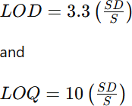

Different concentrations of Lenalidomide in the range of 2–4 µg/mL were prepared from the stock solution and injected into the system. The obtained results are listed in Table 5.9.

System Suitability Test
System suitability tests were performed to assure the chromatographic system’s proper functioning. Table 5.10 shows the results of analyses of previously prepared solutions under optimized chromatographic conditions.

Ruggedness
Ruggedness of the method was checked by analyzing a 6 µg/mL Lenalidomide solution under the same experimental conditions by two different analysts. For solutions of the same concentration, determinations of peak area were made six times. The results are given in Table 5.11.

Robustness
Robustness was evaluated by introducing minor variations in chromatographic conditions and observing the effect on the peak area. The experiments were carried out by altering the flow rate, mobile phase composition, and temperature during the analysis of 6 µg/mL Lenalidomide solution. For each alteration, the analysis was carried out six times, and the results were recorded in Table 5.12.
Table 5.1: Optimization of Mobile Phase Composition and Flow Rate for RP-HPLC Method Development

Sr.
no |  | (%) |  | time
 |  |  |  |  | Asymmetrical
1 | ACN: H2O | 80:20 | 0.8mL/min | 4.7 | peak with slight
 |  |  |  |  | tailing
2 | ACN: H2O | 70:30 | 0.8mL/min | 3.9 | Peak Splitting
3 | MeOH : H2O  (pH 9) | 80:20 | 0.7mL/min | 6.4 | Asymmetrical  peak
4 | MeOH: H2O  (pH 9) | 80:20 | 0.8mL/min | 4.1 | Asymmetrical  peak
5 | MeOH : H2O  (pH 9) | 80:20 | 0.8 mL/min | 5.5 | Asymmetrical  peak
6 | MeOH : H2O | 80:20 | 1.0 mL/min | 4.7 | Asymmetrical

Mobile Phase
Proportion
Flow rate
Retention
Observation

(pH 9) peak, less Rt

MeOH : H2O

7
(pH 9)
70:30 1.0 mL/min 6.6
Well resolved symmetric peak.

Table 5.2: Final Optimized Conditions for RP-HPLC method Chromatographic Mode Chromatographic Conditions HPLC System Agilent Tech. Gradient System (1100)

Detector
Data processor
UV (DAD) G13148 CHEMSTATION 10.1

Column Inertsil C8 column (250 mm x 4.6 mm 5 µm)
Mobile phase Methanol: Water (70: 30 v/v) pH 9
Detection wavelength 395 nm
Flow rate 1.0 mL/min
Injection Volume 20μL

Table 5.3: Linearity Studies

Conc.(μg/mL) | Mean peak area ± SD | % RSD(n=5)
2 | 77379.67± 1333.66 | 1.72
4 | 163001.00± 3096.11 | 1.90
6 | 260331.33± 3258.40 | 1.25
8 | 356724.67± 4768.17 | 1.34
10 | 447256.00± 5385.10 | 1.20
12 | 555366.67± 6964.69 | 1.25
n- number of determinations

Table 5.4: Analysis of Bulk Material

Conc. (μg/mL) | Amount found (μg/mL) | % Amount found
6 | 5.95 | 99.15
6 | 5.96 | 99.32
6 | 5.93 | 98.84
6 | 6.11 | 101.76
6 | 6.02 | 100.30
6 | 5.97 | 99.48
Mean ± SD | 5.99 ± 0.065 | 99.81 ± 1.075
% RSD | 1.08 | 1.08
Table 5.5: Analysis of Capsule Formulation
Conc. (μg/mL) | Amount found (μg/mL) | % Amount found
6 | 6.10 | 100.17
6 | 6.04 | 98.79
6 | 6.11 | 99.92
6 | 6.01 | 101.03
6 | 6.08 | 100.88
6 | 6.07 | 99.02
Mean ± SD | 6.07 ± 0.038 | 99.97 ± 0.629
%RSD | 0.62 | 0.62

Table 5.6: Recovery Studies

Amount in % | Initial amount  (μg/mL) (n=3) | Amount added  (μg/mL) | % Recovered | % RSD
80 | 4 | 3.2 | 100.97 | 0.60
100 | 4 | 4 | 99.29 | 1.23
120 | 4 | 4.8 | 100.70 | 0.85
n- Number of determinations

Table 5.7: Repeatability Studies

 | Conc. (μg/mL) |  | Amount found (μg/mL) |  | % Amount found
 | 6 |  | 5.92 |  | 100.82
 | 6 |  | 6.10 |  | 99.50
 | 6 |  | 6.07 |  | 98.88
 | 6 |  | 5.96 |  | 99.04
 | 6 |  | 6.00 |  | 100.37
 | 6 |  | 6.09 |  | 99.95
 | Mean ± SD |  | 6.02± 0.076 |  | 100.40±1.261
 | %RSD |  | 1.26 |  | 1.26
 | Table 5.8: Precision Studies
Precision Studies |  | Concentration (µg/mL) |  | Amount found (μg/mL) | % Amount found | % RSD
Intra-day |  | 4 |  | 3.95 | 99.68 | 1.08
Precision |  | 6 |  | 5.98 | 100.12 | 1.29
 |  | 8 |  | 8.02 | 99.45 | 1.21
Inter-day |  | 4 |  | 3.96 | 99.36 | 0.98
Precision |  | 6 |  | 6.02 | 99.81 | 1.62
 |  | 8 |  | 7.85 | 100.45 | 0.57

Table 4.9: Sensitivity Studies

LOD (μg/ml) LOQ (μg/ml)

0.13 0.39

Table 4.10: System Suitability studies

Parameters | Estimates
Retention time (Rt) | 6.64
Theoretical Plates (N) | 3728
Tailing factor (T) | 1.23
Capacity factor | 1.09

Table 5.11: Ruggedness Studies

Conc. (μg/mL) | Analysts | Amount Found (%) ± S.D. | %RSD [n=6]
6 | I | 98.93± 0.26 | 0.26
6 | II | 100.84± 0.75 | 0.74

Table 5.12: | Robustness Studies
Sr. No. | Parameter | % RSD
1. | Mobile phase composition  a) Methanol : Water (78: 22 v/v) | 0.11
 | b) Methanol : Water (82: 18 v/v) | 0.12
2. | Column Temperature (oC)  a) 32 | 0.23
 | b) 28 | 0.34
3. | Change in Flow Rate  a) 0.9 | 0.42
 | b) 1.1 | 0.26

Chromatograms showing trials :
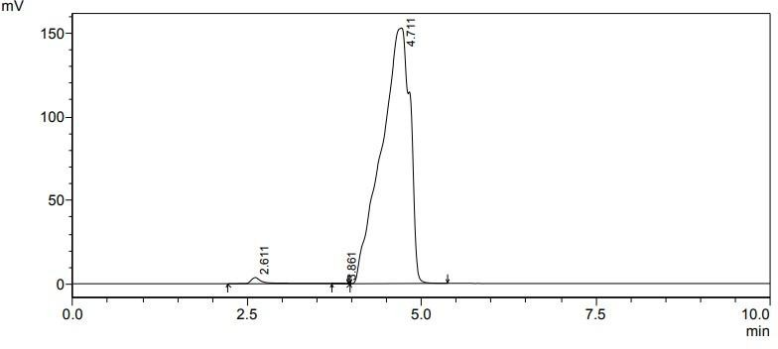
Figure 5.A.a: Trial I -Mobile phase composition acetonitrile: water (80:20 v/v)
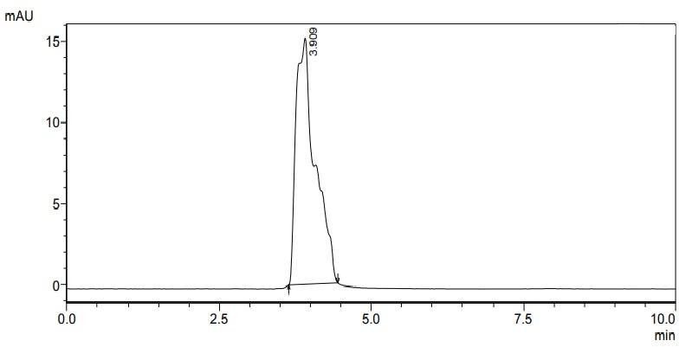
Figure 5.A.b: Trial II -Mobile phase composition acetonitrile: water (70: 30 v/v)

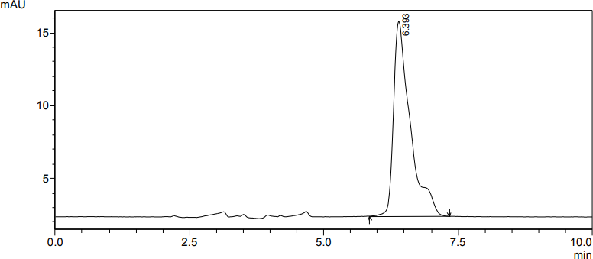
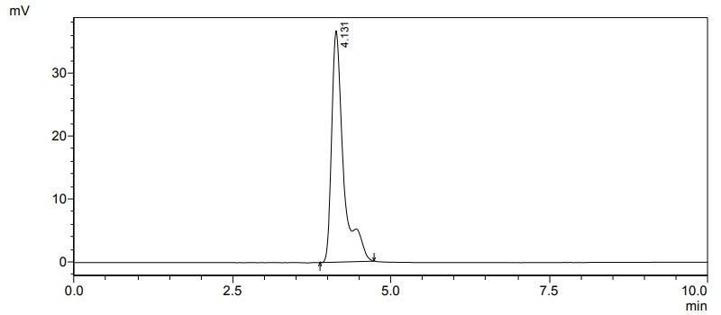
Figure 5.A.c: Trial III - Mobile phase composition methanol: water (80: 20 v/v)
Figure 5.A.d: Trial IV-Mobile phase composition methanol: water (80:20 v/v) (pH 9)

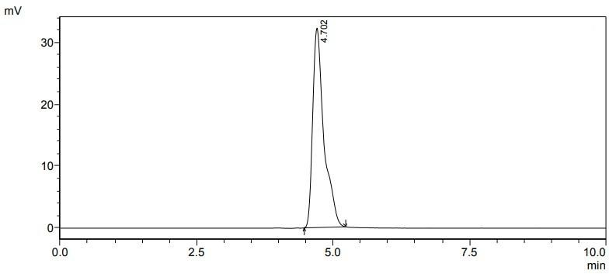
Figure 5.A.e: Trial V- Mobile phase composition methanol: water (70:30 v/v) (pH 9)
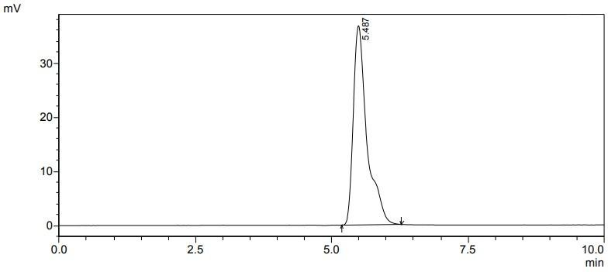
Figure 5.A.f: Trial IV-Mobile phase composition methanol: water (70:30 % v/v) (pH 9)

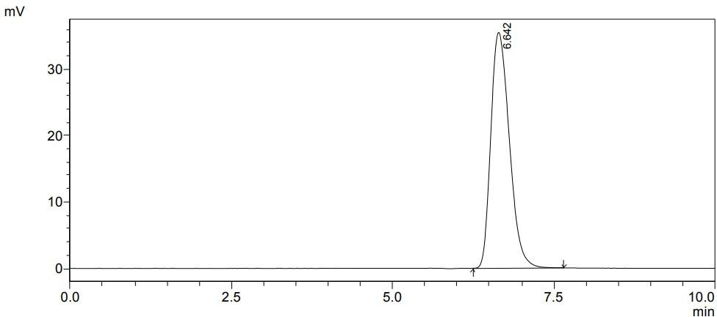
Figure 5.B: Chromatogram of Lenalidomide methanol: water (70:30 v/v) (pH 9)
Concentration (µg/ml)
14
12
10
8
6
4
2
0
0.00
y = 47701x - 23899
R² = 0.9991
600000.00

500000.00

400000.00

300000.00

200000.00

100000.00
Peak Area

Figure 5.C: Calibration Curve for Lenalidomide

Method 2: Development and Validation of UV-Spectrophotometric Method for Determination of Lenalidomide in Bulk and Tablets

Materials
Working standards of pharmaceutical-grade Lenalidomide were provided as kind gifts from Nacto Pharma Ltd. in India. All chemicals and reagents were purchased from Merck chemicals India of analytical grade. Lenalidomide Tablets Lenangio® (label claim 10 mg) were purchased from a local market.

Instrumentation
SHIMADZU AUX – 120 (Weighing Balance) Shimadzu UV- Visible Spectrophotometer 1900 UV-visible double beam spectrophotometer
- Software UV Probe 2.21
- Matched quartz cells 1 cm
- Wavelength range 200 -800 nm
- Lamp: 50 w, Deuterium Lamp
- Detector: Silicon Photodiode
- Cell holder: 1 mm wide, 12 mm high
- Resolution: 1 nm

Experimental
Preliminary solubility studies and selection of solvent Selection of Solvent
The selection of solvent was done after checking the solubility of pure drug in different solvents and finally methanol was selected as solvent for establishing spectral characteristics of Lenalidomide.

Preparation of Stock Standard Solution of Lenalidomide
A stock solution of lenalidomide was prepared by dissolving 10 mg of the pure drug in methanol in a clean and dry 100 mL volumetric flask to obtain a final concentration of 100 μg/mL.

Determination of λ max
To determine λ max of Lenalidomide, the suitable dilution was prepared from the previously prepared stock solution. In particular, 1 mL of the stock solution was transferred to 10 mL volumetric flask and diluted to the final volume with methanol to obtain the solution with the final concentration 10 µg/mL. The solution was then scanned in the UVvisible spectrophotometer within the range 200-800 nm in UV spectrum mode. According to the UV absorption spectrum, the wavelength of maximum absorbance (λ max) of Lenalidomide was determined as 395 nm, which was selected for the subsequent spectroscopic analysis. The zero-order UV absorption spectrum of Lenalidomide is represented in Figure 5.d.

Linearity Study
The linearity of the method was investigated for Lenalidomide from the concentration range of 10-60 µg/mL. Solutions of different concentrations were prepared and diluted by accurate pipetting 1.0-6.0 mL of the stock solution in separate 10 mL volumetric flasks up to the mark with methanol. The absorbance of the diluted solutions was measured at the predetermined λmax of 395 nm against a blank solution. A calibration curve was obtained by plotting absorbance values against concentrations. The slope and intercept of the regression line and the corresponding standard deviations were calculated. Calibration data and linearity curve are presented in Table 5.13 and Fig 5.e.

Analysis of bulk material
Accurately weighed 10 mg of Lenalidomide was transferred into 100 ml volumetric flask and dissolved in methanol by vigorous shaking. The volume was then adjusted to the mark with the same solvent. Dilution of 3 ml of this solution was made up to 10 ml with the same solution to obtain the second solution. The solutions were then scanned using a UV Spectrophotometer at wavelengths of 400-200 nm again against the solvent as blank. The results are as presented in Table 5.14 below.

Method Validation
For criteria including linearity, accuracy, precision, sensitivity, and ruggedness, the suggested analytical method was verified in accordance with ICH guidelines.
Accuracy
The accuracy of the method was checked using recovery studies at three concentrations: 80%, 100%, and 120%. An accurately measured quantity of standard lenalidomide was added to a pre-analyzed sample solution containing 20 μg/mL lenalidomide, after which the mixture was reanalyzed using the developed method. The results of recovery studies confirmed the accuracy of the method.

Precision
The precision of the method was estimated through the evaluation of repeatability, intra-day precision, and inter-day precision. Repeatability was checked by analyzing a solution of 30 μ g/mL of lenalidomide in triplicate, while intra-day precision experiments were carried out by three-time analysis of lenalidomide solution of 20, 30, and 40 μ g/mL on the same day. Moreover, the inter-day precision of the method was estimated through the analysis of the same solutions with concentrations of 20, 30, and 40 μ g/mL of lenalidomide three times a day for three consecutive days. As a result, it was found that the newly developed method possesses good precision.

Sensitivity
The method’s sensitivity is determined by calculating the lowest concentration of the tested pesticide (limit of detection – LOD) and the level at which the tested pesticide can be reliably measured (limit of quantification – LOQ). For the purpose of determining the mentioned parameters, diluted solutions (10-20 µg/ml) were used, followed by constructing a calibration graph. Thus, the LOD and LOQ were calculated according to the following formulas:
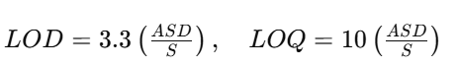
where ASD represents the average standard deviation of the absorbance or peak area values (n = 3), considered as the measure of noise, and S denotes the slope of the calibration curve. The LOD and LOQ values for lenalidomide were found to be 0.50 μg/mL and 1.51 μg/mL, respectively.

Ruggedness
Ruggedness of the proposed method was tested by two different analysts using the same model of UV spectrophotometer at the same operating conditions. The study was carried out at lenalidomide concentration of 30 μg/mL. As a result, it was found that the method is rugged and reproducible under routine laboratory conditions.

Table 5.13: Linearity Studies of Lenalidomide

Conc. of | Zero Order UV-Spectrophotometry | Method
Lenalidomide | Mean Absorbance | % RSD
(μg/mL) | ± SD | [n=5]
10 | 0.165 ± 0.0015 | 0.90
20 | 0.323 ± 0.0021 | 0.64
30 | 0.515 ± 0.0030 | 0.59
40 | 0.684 ± 0.0033 | 0.48
50 | 0.870 ± 0.0058 | 0.67
60 | 1.026 ± 0.0062 | 0.39
n-number of determinations

Table 5.14: Analysis of Bulk Material Drug
Conc.  (μg/mL) |  | Amt. found  (μg/mL) | % Amt. found
30 |  | 29.90 | 99.66
30 |  | 29.84 | 99.47
Lenalidomide 30 |  | 30.01 | 100.04
30 |  | 30.07 | 100.23
30 |  | 30.13 | 100.42
30 |  | 30.01 | 100.04
Mean ±SD |  | 29.99 ±0.10 | 99.96 ±0.35
% RSD |  | 0.35 | 0.35

n- number of determinations

Table 5.15: Analysis of Capsule Formulation

Drug | Conc. (μg/mL) | Amount found (μg/mL) | % Amount found
 | 40 | 40.30 | 100.74
 | 40 | 40.24 | 100.60
 | 40 | 40.75 | 101.89
Lenalidomide | 40 | 40.18 | 100.46
 | 40 | 40.58 | 101.46
 | 40 | 39.95 | 99.89
 | Mean ± SD | 40.34± 0.29 | 100.84± 0.72
 | % RSD | 0.71 | 0.71
n- number of determinations Table 5.16: Recovery Studies
Drug | Initial amount  (μg/mL) | Amount added  (μg/mL) |  | Amount Recovered  (μg/mL) | %  recovery | % RSD [n=3]
 | 20 | 16 |  | 16.16 | 101.02 | 1.14
Method I | 20 | 20 |  | 20.03 | 100.15 | 1.72
 | 20 | 24 |  | 23.95 | 99.81 | 1.67
n- number of determinations
Table 5.17: Repeatability Studies
Drug Conc. (μg/mL) |  |  | Amount found (μg/mL) |  | % Amount found
30 |  |  | 30.13 |  | 100.42
30 |  |  | 30.30 |  | 100.99
PMD 30 |  |  | 30.30 |  | 100.99
30 |  |  | 30.47 |  | 101.56
30 |  |  | 30.47 |  | 101.56
30 |  |  | 30.41 |  | 101.37
Mean ± SD |  |  | 30.34± 0.13 |  | 101.15± 0.44
% RSD |  |  | 0.43 |  | 0.43

n-number of determinations

Table 5.18: Precision Studies

Conc.
Amount found
% Amount
% RSD

(µg/mL) | (μg/mL) | found | [n=3]
Intra Day Precision
20 | 19.90 | 99.52 | 1.13
30 | 30.02 | 100.08 | 1.25
40 | 40.16 | 100.41 | 0.71
Interday Precision
20 | 19.78 | 98.91 | 1.33
30 | 30.46 | 101.52 | 1.05
40 | 40.71 | 101.77 | 0.95

Table 5.19: Ruggedness Studies

Parameters | [%] Amount  found ± SD | % RSD  [ n=6]
Analyst I | 100.93 ± 0.81 | 0.80
Analyst II | 98.96 ± 0.68 | 0.69

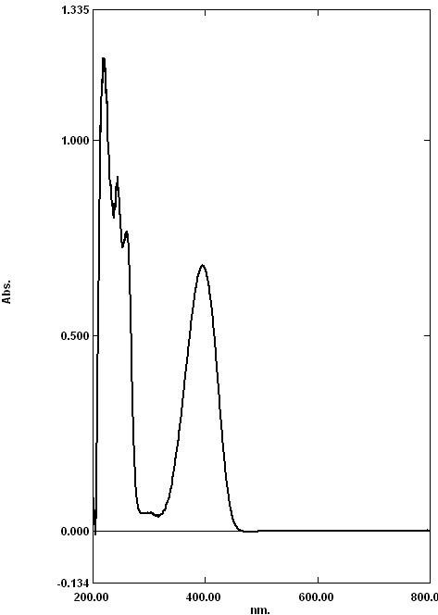
Figure 4.3.A: UV spectrum of Lenalidomide showing λ max at 395.00 nm in Methanol
Zero order absorbance method
1.200
1.000
0.800
0.600
0.400
0.200
y = 0.0175x - 0.0142 R² = 0.9993
0.000
0
20
Conc(µg/ml)
40
60
80
Absorance

Figure 4.3.C: Calibration Curve of Lenalidomide.

References
- F. A. Settal., Handbook of instrumental techniques of analytical chemistry, 1st edition (2004) 19-21
- R. D. Brawn In: Introduction to instrumental analysis. Pharma book syndicate, Hydrabad, (2006) 1-7
- Y. Anjeneyulu, K. Chandrasekhar, V. Manikam. A textbook of Analytical Chemistry. Pharma Book Syndicate; 2005, 3-10
- G. Christian. Analytical Chemistry. 5th ed. John Wiley and Sons, Inc. New York; 2001, 1-3.
- Kazakevich Y., Introduction to HPLC process [serial online]. Available from URL:http://hplc.chem.shu.edu/NEW/Graduate/Modern.Sep.2006/Lect.%201%20Intro%2 0 (2-day).ppt
- D. Skoog. J. Leqary. Principle of Instrumental Analysis. 54 thed. Thomson Asia PvtLtd.Singapore; 2004, 3-8.
- R. D. Brawn, In: Introduction to instrumental analysis. Pharma book syndicate, Hyderabad, 2006, pp. 1 - 7.
- B. K. Sharma, Instrumental Method of chemical Analysis, Goel Publishing Housing, Krishna Prakashan Ltd., 2002, pp. 3.
- F. Settle, Handbook of Instrumental Techniques of Analytical Chemistry, 2004, pp. 19-21 609-617.
- E. Katz, Quantitative Analysis Using Chromatographic Techniques, Wiley India Pvt. Ltd.: 2009, pp. 193 -211.
- D. A. Skoog, F. J. Holler and T.A. Nieman, Principles of Instrumental Analysis, 5th edn., Thomson Brook/cole, 2005, pp. 674-696.
- K. A. Connors, Liquid Chromatography- A Textbook of Pharmaceutical Analysis, 3rd edn., Willey Interscience, New York, 1999, pp. 373-438.
- H. Beckett, J. B. Stenlake, Practical Pharmaceutical Chemistry, 4thedn., Part II, CBS Publications and Distributors, New Delhi, 1997, pp. 1, 275-300.

- E. Heftman, Chromatography- Fundamentals & applications of Chromatography and Related differential migration methods, 6thedn, Elsevier, Amsterdam, Vol. 69A, 2004,
  - pp. 253-291.
- P. D. Sethi, Introduction – High-Performance Liquid Chromatography, 1stedn, CBS Publishers, New Delhi, , 2001, pp.1-28.
- J. Swadesh, HPLC –Practical and Industrial Applications–CRC Press, Boca Raton, 1997,
  - pp. 20-25.
- P. W. Scott, Liquid Chromatography Column Theory, John Willey and Sons, Chi Chester, 2001, pp. 1-13.
- C. D. Gary, Analytical chemistry, 5th edn. John Wiely& sons, Inc., 2001, pp. 1- 3.
- L. R. Synder, J. J. Kirkland, L. J. Glajch, Practical HPLC Method Development, 2ndedn., John Wiley & sons, Inc, 1997, pp. 21-57, 653-660.
- Reviewer Guidance, Validation of Chromatographic Methods (CDER), Nov.1994
- Vogel’s Text book of quantitative chemical analysis, 5th edn., Longman Group UK Ltd., 1989, pp. 1-5.
- B. K. Sharma, Instrumental Method of chemical Analysis, 21stedn., Goel publishing house, 2002, pp. 9-16.
- P. W Scott, Raymond, Encyclopedia of Chromatography, 10th edn., Marcel Dekker, Inc. USA, 2001, pp. 252-254.
- H. H. Willard, L. L. Merritt, J. A. Dean, and F. A. Settle, Instrumental Method for Analysis, 7th edn, CBS publishers and distributors, New Delhi, 1986, pp. 513-530.
- A. V. Kasture, S. G. Wadodkar, K. R. Mahadik, and H. N. More, Textbook of Pharmaceutical Analysis – II, 11thedn., Published By Nirali Prakashan, 1996, pp. 156- 165.
- E. Heftman, Chromatography- Fundamentals & applications of Chromatography and Related differential migration methods,6thedn., Elsevier, Amsterdam, Vol. 69A, 2004, pp. 72-87.
- www.camag.com
- J. Cazes, P. W. Scott, Raymond, Chromatography Theory, Marcel Decker, Inc, NY, 2002, pp. 443-454.

- P. D. Sethi, HPTLC: Quantitative Analysis of Pharmaceutical formulation, 1stedn., CBS Publications, New Delhi, 1996, pp.162-165.
- E. Stahl, Thin Layer Chromatography: A Laboratory Handbook, 2ndedn, Springer International Edition, pp.1-30
- B. K. Sharma, Instrumental Method of Chemical Analysis, 21th ed., Goel Publishing Housing, 2002, pp. 3.
- A. K. Conners, Textbook of Pharmaceutical Analysis, 3rd ed.; A Wiley- Intersciences Publication, 1999, pp. 616.
- H. Beckett, J. B. Stenlake, Practical Pharmaceutical Chemistry, 4th ed.; Part II, CBS Publications and Distributors: New Delhi, 1997, pp. 275-277.
- H. H. Willard, L. L. Metritt, J. A. Dean, F. A. Settal, Instrumental methods of Analysis, 7th ed., CBS Publishers and Distributers, 1986, pp. 118.
- U S pharmacopoeia 24, Validation of compendia methods, section <1225>, united states pharmacopeialconvension, Rockville, MD, 1999, pp. 2149
- International conference on harmonization (ICH), Q2b: Validation of analytical procedure: Methodology, USFDA federal register, Vol. 62, May 1997, pp. 27463
  - US pharmacopoeia 23, Chromatography section <621>, united states Pharmacopeial Convension, Rockville, MD, 1994, pp. 1776
- International Conference on Harmonization (ICH), Q2A: Text on Validation of Analytical Procedure USFDA federal register, vol 60, May 1995 pp. 11260
- Shabir, G.A., 2003. Validation of high-performance liquid chromatography methods for pharmaceutical analysis: Understanding the differences and similarities between validation requirements of the US Food and Drug Administration, the US Pharmacopeia and the International Conference on Harmonization. Journal of chromatography A, 987(1-2), pp.57-66.
- Armoiry, X., Aulagner, G. and Facon, T., 2008. Lenalidomide in the treatment of multiple myeloma: a review. Journal of clinical pharmacy and therapeutics, 33(3), pp.219-226.
- Li, S., Gill, N. and Lentzsch, S., 2010. Recent advances of IMiDs in cancer therapy. Current Opinion in Oncology, 22(6), pp.579-585.

- Tageja, N., 2011. Lenalidomide-current understanding of mechanistic properties. Anti- Cancer Agents in Medicinal Chemistry-Anti-Cancer Agents), 11(3), pp.315-326.
- Kotla, V., Goel, S., Nischal, S., Heuck, C., Vivek, K., Das, B. and Verma, A., 2009. Mechanism of action of lenalidomide in hematological malignancies. Journal of hematology & oncology, 2, pp.1-10.
- Yang, B., Yu, R.L., Chi, X.H. and Lu, X.C., 2013. Lenalidomide treatment for multiple myeloma: systematic review and meta-analysis of randomized controlled trials. PLoS One, 8(5), p.e64354.
- Ağtaş, Ç. and Atici, E.B., 2025. Development and validation of stability-indicating UHPLC-UV-MS tandem methods for lenalidomide assay, related substances, and genotoxic impurity monitoring. Journal of Pharmaceutical and Biomedical Analysis, 258, p.116757.
- Saxena, J., Saroj, S. and Rajput, S., 2017. Estimation of lenalidomide in bulk and its dosage form using uv spectrophotometric and Rp-Hplc methods. Indo American journal of pharmaceutical research, 3, pp.7938-7945.
- Alzweiri, M., Sweidan, K. and Aqel, Q., 2022. Investigation of the Chemical Stability of Lenalidomide in Methanol/Ethanol Solvents Using RP-HPLC-UV and LC-MS. Jordan Journal of Pharmaceutical Sciences, 15(3), pp.305-314.
- Xu, L., Hu, Y.X., Li, Y.C., Zhang, L., Ai, H.X., Liu, Y.F. and Liu, H.S., 2018. In vitro
  - DNA binding studies of lenalidomide using spectroscopic in combination with molecular docking techniques. Journal of Molecular Structure, 1154, pp.9-18.
- De Novellis, D., Raimondo, A., Serio, B., Baldi, C., Giudice, V., Lembo, S. and Selleri, C., 2024. Lenalidomide‐induced psoriasis in a refractory multiple myeloma patient successfully treated with narrowband ultraviolet B. Photodermatology, Photoimmunology & Photomedicine, 40(3).
- Reddy, L.B., Kumar, N.K., Rao, V.S., & Ramachandran, D. (2012) ‘Development of a Rapid and Sensitive HPLC Assay Method for Lenalidomide Capsules and Its Related Substances’. Journal of Chemistry, 2013, pp. 1–7.
- Rao, B.M., Rao, D.V., & Rao, G.L. (2009) ‘Development of an HPLC Assay Method for Lenalidomide’. Journal of Liquid Chromatography & Related Technologies, 32(11), pp. 1651–1661.

- Sitamahalakshmi, D.S.V.N., Kumar, A.N., & Rao, G.L. (2019) ‘Stability Indicating RP- HPLC Method for Quantitative Estimation of Lenalidomide and Its Impurities in Solid Dosage Form’. Journal of Analytical Chemistry, 74(9), pp. 770–778.
- Patel, M., Patel, H., & Patel, P. (2014) ‘Method development and validation of degradation studies of lenalidomide by RP-HPLC’. International Journal of Pharmaceutical Sciences and Research, 5(8), pp. 3442–3448.
- Sastry, B.S., Reddy, S.P., & Rao, S.S. (2010) ‘NEW SPECTROPHOTOMETRIC METHODS FOR ESTIMATION OF LENALIDOMIDE IN PHARMACEUTICAL
  - FORMULATIONS’. Asian Journal of Pharmaceutical and Clinical Research, 3(3), pp. 81–83.
- Payab, M., Zarghi, A., & Shokri, J. (2014) ‘Development of a reversed-phase HPLC method for determination of related impurities of Lenalidomide’. Research in Pharmaceutical Sciences, 9(4), pp. 273–279.
- Demir, I., Yüce, M., & Dursun, Ö. (2023) ‘Development, validation, and greenness assessment of environmentally friendly analytical methods for the quantification of lenalidomide in pharmaceutical formulations’. Analytical Methods, 15(15), pp. 1957– 1968.
- Cao, Z., Liu, T., Yan, X., & Liu, G. (2018) ‘Simultaneous determination of thirteen related substances in lenalidomide API by a stability-indicating RP-HPLC method’. Journal of Pharmaceutical and Biomedical Analysis, 151, pp. 297–304.
- Alzoman, N.Z., Sultan, M.A., & Al-Shehri, M.M. (2017) ‘A Validated Stability- Indicating and Stereoselective HPLC Method for the Determination of Lenalidomide Enantiomers in Bulk Form and Capsules’. Chirality, 29(1), pp. 19–27.
- Raghu, N.S., Kumar, N.K., Rao, K.S., & Ramachandran, D. (2013) ‘DEGRADATION STUDIES OF HIGHLY POTENT AND LIFE-THREATENING HUMAN BIRTH DEFECT DRUG LENALIDOMIDE BY HPLC AND LC-MS’. Chromatographia, 76(23-24), pp. 1667–1679.
- ALSHEHRT, M.M., Al-Ghorab, M.M., & Al-Shehri, M.M. (2016) ‘STABILITY- INDICATING CAPILLARY ELECTROPHORESIS METHOD WITH PHOTODIODE ARRAY DETECTOR FOR DETERMINATION OF LENALIDOMIDE IN

  - PHARMACEUTICAL PREPARATION’. Analytical Chemistry Letters, 6(3), pp. 317– 334.
- Ponnuru, B., Rao, P.G., & Rao, G.L. (2020) ‘Development and Validation of Stability Indicating Rp-hplc Method for Quantitative Estimation of Lenalidomide in Lenalidomide Capsules Dosage Form’. International Journal of Pharmaceutical Quality Assurance, 11(1), pp. 109–116.
- Reddy, R. et al. (2013) ‘Degradation Studies of Highly Potent and Life-Threatening Human Birth Defect Drug Lenalidomide by HPLC and LLC-MS’. Chromatographia, 76(23-24), pp. 1667–1679.
- Swathi, K., & Madhusudan, B. (2015) ‘METHOD DEVELOPMENT AND VALIDATION FOR THE QUANTITATIVE ESTIMATION OF LENALIDOMIDE IN API FORM AND MARKETED TABLET DOSAGE FORM BY RP-HPLC’.
  - International Journal of Research in Pharmacy and Chemistry, 5(2), pp. 353–359.
- Venkateshwarlu, P., Patel, M., & Patel, H. (2014) ‘Method development and validation of degradation studies of lenalidomide by RP-HPLC’. International Journal of Pharmaceutical Sciences and Research, 5(8), pp. 3442–3448.
- Gupta, A., et al. (no date) ‘Central composite design aided optimization and validation of developed an eco-friendly HPLC method for the quantification of Lenalidomide loaded mesoporous silica nanoparticles’. Journal of Pharmaceutical and Biomedical Analysis (Information regarding year, volume, issue, and page numbers not provided in original text).
- Vardhan, G., Singh, S., & Singh, R.P. (2022) ‘Development and validation of a novel chiral chromatographic method for the separation of lenalidomide enantiomers in human plasma’. Journal of Separation Science, 45(15), pp. 2707–2713.
- Iqbal, M., et al. (2018) ‘Development and validation of ultra-performance liquid chromatographic method with tandem mass spectrometry for determination of lenalidomide in rabbit and human plasma’. Journal of Pharmaceutical and Biomedical Analysis, 154, pp. 20–27.
- Guglieri-López, B., et al. (2016) ‘A wide linearity range method for the determination of lenalidomide in plasma by high-performance liquid chromatography: application to pharmacokinetic studies’. Therapeutic Drug Monitoring, 38(4), pp. 544–549.

- Saxena, J., & Jain, S. (2022) ‘Development and Validation of an Environmentally Benign and Robust Stability Indicating Assay Method for Lenalidomide: Comprehensive Degradation Kinetics Study and Application’. Journal of Pharmaceutical Analysis, 12(6),
  - pp. 917–929.
- Kalpan, K., Sanyal, M., & Kumar, R. (2020) ‘A Simple and Rapid LC-MS/MS Method for Therapeutic Drug Monitoring of Lenalidomide’. Biomedical Chromatography, 34(7),
  - p. e4860.
- Shirman A, Khan GJ, Ansari YA, Qazi S, Inamdar ZE, Siddiqi H, Syed UF, Syed T, Syeda S. DEVELOPMENT AND VALIDATION OF ANALYTICAL METHOD FOR QUANTITATION OF CLOFARABINE. Indian Drugs. 2022 Jan 1;59(1):60.

